Everything except the last two topics (firewalls and SRE) is done. Thanks to Aditya Dasgupta for helping out with the access control and intrusion detection segments. Good luck with the exam!

[Course Intro](https://docs.google.com/document/d/1sZGlq2mAClokmW_5Pdu0_ZlSUqHD_D0PwM5KOq4S5_s/edit#heading=h.tyowil69oqp0)

[Introduction to Computer Security](https://docs.google.com/document/d/1sZGlq2mAClokmW_5Pdu0_ZlSUqHD_D0PwM5KOq4S5_s/edit#heading=h.9zse08k7b2th)

[CIA](https://docs.google.com/document/d/1sZGlq2mAClokmW_5Pdu0_ZlSUqHD_D0PwM5KOq4S5_s/edit#heading=h.6lz5dcetj2ta)

[Terminology](https://docs.google.com/document/d/1sZGlq2mAClokmW_5Pdu0_ZlSUqHD_D0PwM5KOq4S5_s/edit#heading=h.k1s08nhphkxg)

[Historical Cryptography](https://docs.google.com/document/d/1sZGlq2mAClokmW_5Pdu0_ZlSUqHD_D0PwM5KOq4S5_s/edit#heading=h.fl27svj8yswn)

[Overview](https://docs.google.com/document/d/1sZGlq2mAClokmW_5Pdu0_ZlSUqHD_D0PwM5KOq4S5_s/edit#heading=h.bj7v7ya5pfoc)

[Cryptosystem Components (defs)](https://docs.google.com/document/d/1sZGlq2mAClokmW_5Pdu0_ZlSUqHD_D0PwM5KOq4S5_s/edit#heading=h.hm0c59vgilnj)

[Attacks](https://docs.google.com/document/d/1sZGlq2mAClokmW_5Pdu0_ZlSUqHD_D0PwM5KOq4S5_s/edit#heading=h.mm1n5s6w2y2c)

[Classical Cryptography](https://docs.google.com/document/d/1sZGlq2mAClokmW_5Pdu0_ZlSUqHD_D0PwM5KOq4S5_s/edit#heading=h.4zcx1ptpzqsx)

[Definition](https://docs.google.com/document/d/1sZGlq2mAClokmW_5Pdu0_ZlSUqHD_D0PwM5KOq4S5_s/edit#heading=h.cq3gfuax2nw2)

[Transposition Cipher](https://docs.google.com/document/d/1sZGlq2mAClokmW_5Pdu0_ZlSUqHD_D0PwM5KOq4S5_s/edit#heading=h.owh9lwbt9qn0)

[Symmetric Encryption](https://docs.google.com/document/d/1sZGlq2mAClokmW_5Pdu0_ZlSUqHD_D0PwM5KOq4S5_s/edit#heading=h.jgfbs9cnhkjr)

[Block vs. Stream Ciphers](https://docs.google.com/document/d/1sZGlq2mAClokmW_5Pdu0_ZlSUqHD_D0PwM5KOq4S5_s/edit#heading=h.phpb0ua6g8b1)

[DES](https://docs.google.com/document/d/1sZGlq2mAClokmW_5Pdu0_ZlSUqHD_D0PwM5KOq4S5_s/edit#heading=h.kr1e8kj6nl4v)

[AES](https://docs.google.com/document/d/1sZGlq2mAClokmW_5Pdu0_ZlSUqHD_D0PwM5KOq4S5_s/edit#heading=h.4ag2jkt8vkle)

[Block Encryption Modes](https://docs.google.com/document/d/1sZGlq2mAClokmW_5Pdu0_ZlSUqHD_D0PwM5KOq4S5_s/edit#heading=h.th2fvuhbx2jc)

[ECB](https://docs.google.com/document/d/1sZGlq2mAClokmW_5Pdu0_ZlSUqHD_D0PwM5KOq4S5_s/edit#heading=h.iip5i17iogt3)

[CBC](https://docs.google.com/document/d/1sZGlq2mAClokmW_5Pdu0_ZlSUqHD_D0PwM5KOq4S5_s/edit#heading=h.sm57dx9z7hgp)

[Counter Mode](https://docs.google.com/document/d/1sZGlq2mAClokmW_5Pdu0_ZlSUqHD_D0PwM5KOq4S5_s/edit#heading=h.f5zsn98uw62o)

[Public or Asymmetric Cryptography](https://docs.google.com/document/d/1sZGlq2mAClokmW_5Pdu0_ZlSUqHD_D0PwM5KOq4S5_s/edit#heading=h.a5yxk4sjcw79)

[General](https://docs.google.com/document/d/1sZGlq2mAClokmW_5Pdu0_ZlSUqHD_D0PwM5KOq4S5_s/edit#heading=h.utd7t5vo1ugk)

[Public Key overview](https://docs.google.com/document/d/1sZGlq2mAClokmW_5Pdu0_ZlSUqHD_D0PwM5KOq4S5_s/edit#heading=h.1ecfw9rgk4et)

[Diffie-Hellman](https://docs.google.com/document/d/1sZGlq2mAClokmW_5Pdu0_ZlSUqHD_D0PwM5KOq4S5_s/edit#heading=h.9dn99wttr55s)

[RSA](https://docs.google.com/document/d/1sZGlq2mAClokmW_5Pdu0_ZlSUqHD_D0PwM5KOq4S5_s/edit#heading=h.9e9c2mu5ii1a)

[Sign and Encrypt vs. Encrypt and Sign](https://docs.google.com/document/d/1sZGlq2mAClokmW_5Pdu0_ZlSUqHD_D0PwM5KOq4S5_s/edit#heading=h.yxjzh523kggk)

[Crypto Hash](https://docs.google.com/document/d/1sZGlq2mAClokmW_5Pdu0_ZlSUqHD_D0PwM5KOq4S5_s/edit#heading=h.9g9rjj51kkdf)

[Difference from Regular Checksums](https://docs.google.com/document/d/1sZGlq2mAClokmW_5Pdu0_ZlSUqHD_D0PwM5KOq4S5_s/edit#heading=h.6r2etrdgxqsy)

[Keyed/Keyless and Standard Algorithms](https://docs.google.com/document/d/1sZGlq2mAClokmW_5Pdu0_ZlSUqHD_D0PwM5KOq4S5_s/edit#heading=h.b2s9zq1sf6yg)

[Brute Force Attacks](https://docs.google.com/document/d/1sZGlq2mAClokmW_5Pdu0_ZlSUqHD_D0PwM5KOq4S5_s/edit#heading=h.3k0h0dfwm5tq)

[Birthday Attacks/Pigeonhole Principle](https://docs.google.com/document/d/1sZGlq2mAClokmW_5Pdu0_ZlSUqHD_D0PwM5KOq4S5_s/edit#heading=h.jn3zig964rre)

[HMAC](https://docs.google.com/document/d/1sZGlq2mAClokmW_5Pdu0_ZlSUqHD_D0PwM5KOq4S5_s/edit#heading=h.vx5n5g5e7mhd)

[Crypto Strengths](https://docs.google.com/document/d/1sZGlq2mAClokmW_5Pdu0_ZlSUqHD_D0PwM5KOq4S5_s/edit#heading=h.589fggty4qg1)

[Brute-Force Key Search (symmetric algorithms)](https://docs.google.com/document/d/1sZGlq2mAClokmW_5Pdu0_ZlSUqHD_D0PwM5KOq4S5_s/edit#heading=h.molivkedb1yb)

[Attack Hard Problem (asymmetric algorithms)](https://docs.google.com/document/d/1sZGlq2mAClokmW_5Pdu0_ZlSUqHD_D0PwM5KOq4S5_s/edit#heading=h.tt3k4bf2btxk)

[Crypto Hash](https://docs.google.com/document/d/1sZGlq2mAClokmW_5Pdu0_ZlSUqHD_D0PwM5KOq4S5_s/edit#heading=h.9q1rtjiigwmq)

[Weak-Collision Resistance](https://docs.google.com/document/d/1sZGlq2mAClokmW_5Pdu0_ZlSUqHD_D0PwM5KOq4S5_s/edit#heading=h.qvmwbp9vsiky)

[Strong-Collision Resistance](https://docs.google.com/document/d/1sZGlq2mAClokmW_5Pdu0_ZlSUqHD_D0PwM5KOq4S5_s/edit#heading=h.y1amz6agodcb)

[Identity and Key Management](https://docs.google.com/document/d/1sZGlq2mAClokmW_5Pdu0_ZlSUqHD_D0PwM5KOq4S5_s/edit#heading=h.sxhgzzklbp5c)

[Digital Signatures](https://docs.google.com/document/d/1sZGlq2mAClokmW_5Pdu0_ZlSUqHD_D0PwM5KOq4S5_s/edit#heading=h.mkmmmxydpekz)

[Long Lived vs. Session Keys](https://docs.google.com/document/d/1sZGlq2mAClokmW_5Pdu0_ZlSUqHD_D0PwM5KOq4S5_s/edit#heading=h.9dlmotpck4er)

[Randomness and pseudo random](https://docs.google.com/document/d/1sZGlq2mAClokmW_5Pdu0_ZlSUqHD_D0PwM5KOq4S5_s/edit#heading=h.u6przg4vki02)

[Key/identity Distribution](https://docs.google.com/document/d/1sZGlq2mAClokmW_5Pdu0_ZlSUqHD_D0PwM5KOq4S5_s/edit#heading=h.d2tmbkk8p8cz)

[Needham-Schroeder](https://docs.google.com/document/d/1sZGlq2mAClokmW_5Pdu0_ZlSUqHD_D0PwM5KOq4S5_s/edit#heading=h.c40r4mur8arl)

[Kerberos](https://docs.google.com/document/d/1sZGlq2mAClokmW_5Pdu0_ZlSUqHD_D0PwM5KOq4S5_s/edit#heading=h.tv9n0jktxgbp)

[PKI Trust Models](https://docs.google.com/document/d/1sZGlq2mAClokmW_5Pdu0_ZlSUqHD_D0PwM5KOq4S5_s/edit#heading=h.dqadnsr72eu6)

[Authentication](https://docs.google.com/document/d/1sZGlq2mAClokmW_5Pdu0_ZlSUqHD_D0PwM5KOq4S5_s/edit#heading=h.fuf5xtl9h5pb)

[Establishing IDs](https://docs.google.com/document/d/1sZGlq2mAClokmW_5Pdu0_ZlSUqHD_D0PwM5KOq4S5_s/edit#heading=h.lsxileyu1f9h)

[Spent a lot of time on passwords](https://docs.google.com/document/d/1sZGlq2mAClokmW_5Pdu0_ZlSUqHD_D0PwM5KOq4S5_s/edit#heading=h.7qh7pt3pekr7)

[Vulnerabilities](https://docs.google.com/document/d/1sZGlq2mAClokmW_5Pdu0_ZlSUqHD_D0PwM5KOq4S5_s/edit#heading=h.kvmhaafpzu8h)

[Salt](https://docs.google.com/document/d/1sZGlq2mAClokmW_5Pdu0_ZlSUqHD_D0PwM5KOq4S5_s/edit#heading=h.z20djifpx19x)

[Challenge Response](https://docs.google.com/document/d/1sZGlq2mAClokmW_5Pdu0_ZlSUqHD_D0PwM5KOq4S5_s/edit#heading=h.jhohtvc4p5cz)

[Biometrics](https://docs.google.com/document/d/1sZGlq2mAClokmW_5Pdu0_ZlSUqHD_D0PwM5KOq4S5_s/edit#heading=h.ipqosq9u6d4s)

[SSL/IPSec](https://docs.google.com/document/d/1sZGlq2mAClokmW_5Pdu0_ZlSUqHD_D0PwM5KOq4S5_s/edit#heading=h.wp58qn4skk9a)

[Comparison](https://docs.google.com/document/d/1sZGlq2mAClokmW_5Pdu0_ZlSUqHD_D0PwM5KOq4S5_s/edit#heading=h.3j9kgv3obyh0)

[Handshake Protocol](https://docs.google.com/document/d/1sZGlq2mAClokmW_5Pdu0_ZlSUqHD_D0PwM5KOq4S5_s/edit#heading=h.flpreff1sut2)

[IPSec](https://docs.google.com/document/d/1sZGlq2mAClokmW_5Pdu0_ZlSUqHD_D0PwM5KOq4S5_s/edit#heading=h.ouzad3whvfxt)

[Access Control](https://docs.google.com/document/d/1sZGlq2mAClokmW_5Pdu0_ZlSUqHD_D0PwM5KOq4S5_s/edit#heading=h.r4qdt41qmg9n)

[AAA](https://docs.google.com/document/d/1sZGlq2mAClokmW_5Pdu0_ZlSUqHD_D0PwM5KOq4S5_s/edit#heading=h.w7w7yungnilt)

[DAC/MAC/RBAC](https://docs.google.com/document/d/1sZGlq2mAClokmW_5Pdu0_ZlSUqHD_D0PwM5KOq4S5_s/edit#heading=h.axi424s434fp)

[Access Matrix](https://docs.google.com/document/d/1sZGlq2mAClokmW_5Pdu0_ZlSUqHD_D0PwM5KOq4S5_s/edit#heading=h.1op8n8hx6n6a)

[Access Control Lists](https://docs.google.com/document/d/1sZGlq2mAClokmW_5Pdu0_ZlSUqHD_D0PwM5KOq4S5_s/edit#heading=h.9gj7d9n3uyj)

[Capabilities](https://docs.google.com/document/d/1sZGlq2mAClokmW_5Pdu0_ZlSUqHD_D0PwM5KOq4S5_s/edit#heading=h.evdgw3z1bfkr)

[RBAC](https://docs.google.com/document/d/1sZGlq2mAClokmW_5Pdu0_ZlSUqHD_D0PwM5KOq4S5_s/edit#heading=h.4ch9j5ul7cie)

[Add Intermediate Role Layer (And basics of RABC)](https://docs.google.com/document/d/1sZGlq2mAClokmW_5Pdu0_ZlSUqHD_D0PwM5KOq4S5_s/edit#heading=h.j9d8yb7rcibd)

[Models of RBAC](https://docs.google.com/document/d/1sZGlq2mAClokmW_5Pdu0_ZlSUqHD_D0PwM5KOq4S5_s/edit#heading=h.6kd14bi24fvt)

[NIST Standard](https://docs.google.com/document/d/1sZGlq2mAClokmW_5Pdu0_ZlSUqHD_D0PwM5KOq4S5_s/edit#heading=h.n4u2wi6j3bxa)

[Mandatory Access Controls](https://docs.google.com/document/d/1sZGlq2mAClokmW_5Pdu0_ZlSUqHD_D0PwM5KOq4S5_s/edit#heading=h.rajwipxiv7zb)

[Bell-LaPadula Confidentiality Model](https://docs.google.com/document/d/1sZGlq2mAClokmW_5Pdu0_ZlSUqHD_D0PwM5KOq4S5_s/edit#heading=h.xcy7k3c6ixn1)

[Biba Integrity Model](https://docs.google.com/document/d/1sZGlq2mAClokmW_5Pdu0_ZlSUqHD_D0PwM5KOq4S5_s/edit#heading=h.6dl64vkuucnn)

[Chinese Wall Model](https://docs.google.com/document/d/1sZGlq2mAClokmW_5Pdu0_ZlSUqHD_D0PwM5KOq4S5_s/edit#heading=h.wcucwsnchmwi)

[Database Security](https://docs.google.com/document/d/1sZGlq2mAClokmW_5Pdu0_ZlSUqHD_D0PwM5KOq4S5_s/edit#heading=h.ssgoxnm2cl5b)

[Access Control Model](https://docs.google.com/document/d/1sZGlq2mAClokmW_5Pdu0_ZlSUqHD_D0PwM5KOq4S5_s/edit#heading=h.qaae37co2klv)

[Statistical Databases](https://docs.google.com/document/d/1sZGlq2mAClokmW_5Pdu0_ZlSUqHD_D0PwM5KOq4S5_s/edit#heading=h.14hx91ex13l4)

[SQL Injection Attack](https://docs.google.com/document/d/1sZGlq2mAClokmW_5Pdu0_ZlSUqHD_D0PwM5KOq4S5_s/edit#heading=h.fducsx6sya1y)

[Malicious Code](https://docs.google.com/document/d/1sZGlq2mAClokmW_5Pdu0_ZlSUqHD_D0PwM5KOq4S5_s/edit#heading=h.6r3309eq8vlv)

[Types of Malicious Code](https://docs.google.com/document/d/1sZGlq2mAClokmW_5Pdu0_ZlSUqHD_D0PwM5KOq4S5_s/edit#heading=h.3qqffxkhvnry)

[Trojans](https://docs.google.com/document/d/1sZGlq2mAClokmW_5Pdu0_ZlSUqHD_D0PwM5KOq4S5_s/edit#heading=h.amhewvdl008d)

[Rootkits](https://docs.google.com/document/d/1sZGlq2mAClokmW_5Pdu0_ZlSUqHD_D0PwM5KOq4S5_s/edit#heading=h.s04m1waioppc)

[Viruses](https://docs.google.com/document/d/1sZGlq2mAClokmW_5Pdu0_ZlSUqHD_D0PwM5KOq4S5_s/edit#heading=h.lr5tueufujoj)

[Worms](https://docs.google.com/document/d/1sZGlq2mAClokmW_5Pdu0_ZlSUqHD_D0PwM5KOq4S5_s/edit#heading=h.z71kkjb7cf89)

[Botnets](https://docs.google.com/document/d/1sZGlq2mAClokmW_5Pdu0_ZlSUqHD_D0PwM5KOq4S5_s/edit#heading=h.8eyeahh5rge6)

[Propagation Techniques vs. Hiding Techniques](https://docs.google.com/document/d/1sZGlq2mAClokmW_5Pdu0_ZlSUqHD_D0PwM5KOq4S5_s/edit#heading=h.9hfb56sy5537)

[Zero Day Exploit](https://docs.google.com/document/d/1sZGlq2mAClokmW_5Pdu0_ZlSUqHD_D0PwM5KOq4S5_s/edit#heading=h.bik670ymnhop)

[Avoiding Signature Scanning](https://docs.google.com/document/d/1sZGlq2mAClokmW_5Pdu0_ZlSUqHD_D0PwM5KOq4S5_s/edit#heading=h.ll27i1q6z6cu)

[Hit list](https://docs.google.com/document/d/1sZGlq2mAClokmW_5Pdu0_ZlSUqHD_D0PwM5KOq4S5_s/edit#heading=h.wsqsubh8x8os)

[Defenses](https://docs.google.com/document/d/1sZGlq2mAClokmW_5Pdu0_ZlSUqHD_D0PwM5KOq4S5_s/edit#heading=h.x853gn9u1ys6)

[Rootkit](https://docs.google.com/document/d/1sZGlq2mAClokmW_5Pdu0_ZlSUqHD_D0PwM5KOq4S5_s/edit#heading=h.yvha8z4vl410)

[Virus Precautions/Signature Scanning](https://docs.google.com/document/d/1sZGlq2mAClokmW_5Pdu0_ZlSUqHD_D0PwM5KOq4S5_s/edit#heading=h.yna5ww2hgt3r)

[IPv6](https://docs.google.com/document/d/1sZGlq2mAClokmW_5Pdu0_ZlSUqHD_D0PwM5KOq4S5_s/edit#heading=h.reu8o556dkc)

[Buffer Overflow](https://docs.google.com/document/d/1sZGlq2mAClokmW_5Pdu0_ZlSUqHD_D0PwM5KOq4S5_s/edit#heading=h.9bbd16pic0d3)

[Stack Overflow](https://docs.google.com/document/d/1sZGlq2mAClokmW_5Pdu0_ZlSUqHD_D0PwM5KOq4S5_s/edit#heading=h.z1ddruypxv9l)

[Shell Code](https://docs.google.com/document/d/1sZGlq2mAClokmW_5Pdu0_ZlSUqHD_D0PwM5KOq4S5_s/edit#heading=h.obmybct4vgqx)

[Defenses](https://docs.google.com/document/d/1sZGlq2mAClokmW_5Pdu0_ZlSUqHD_D0PwM5KOq4S5_s/edit#heading=h.obmybct4vgqx)

[Compile Time](https://docs.google.com/document/d/1sZGlq2mAClokmW_5Pdu0_ZlSUqHD_D0PwM5KOq4S5_s/edit#heading=h.obmybct4vgqx)

[Run Time](https://docs.google.com/document/d/1sZGlq2mAClokmW_5Pdu0_ZlSUqHD_D0PwM5KOq4S5_s/edit#heading=h.obmybct4vgqx)

[Network Security](https://docs.google.com/document/d/1sZGlq2mAClokmW_5Pdu0_ZlSUqHD_D0PwM5KOq4S5_s/edit#heading=h.k03h7e4ev1d1)

[Denial of Service Attacks](https://docs.google.com/document/d/1sZGlq2mAClokmW_5Pdu0_ZlSUqHD_D0PwM5KOq4S5_s/edit#heading=h.pvpv92a3277u)

[Address Spoofing](https://docs.google.com/document/d/1sZGlq2mAClokmW_5Pdu0_ZlSUqHD_D0PwM5KOq4S5_s/edit#heading=h.pvpv92a3277u)

[ARP cache poisoning](https://docs.google.com/document/d/1sZGlq2mAClokmW_5Pdu0_ZlSUqHD_D0PwM5KOq4S5_s/edit#heading=h.pvpv92a3277u)

[Smurf](https://docs.google.com/document/d/1sZGlq2mAClokmW_5Pdu0_ZlSUqHD_D0PwM5KOq4S5_s/edit#heading=h.pvpv92a3277u)

[Open Relay DNS](https://docs.google.com/document/d/1sZGlq2mAClokmW_5Pdu0_ZlSUqHD_D0PwM5KOq4S5_s/edit#heading=h.pvpv92a3277u)

[DNS Cache Poisoning](https://docs.google.com/document/d/1sZGlq2mAClokmW_5Pdu0_ZlSUqHD_D0PwM5KOq4S5_s/edit#heading=h.pvpv92a3277u)

[TCP-Based Attacks](https://docs.google.com/document/d/1sZGlq2mAClokmW_5Pdu0_ZlSUqHD_D0PwM5KOq4S5_s/edit#heading=h.pvpv92a3277u)

[Syn Spoofing/Flood](https://docs.google.com/document/d/1sZGlq2mAClokmW_5Pdu0_ZlSUqHD_D0PwM5KOq4S5_s/edit#heading=h.xydnfpr3pdfj)

[Reset](https://docs.google.com/document/d/1sZGlq2mAClokmW_5Pdu0_ZlSUqHD_D0PwM5KOq4S5_s/edit#heading=h.81q7g06bwj7z)

[Session Hijacking](https://docs.google.com/document/d/1sZGlq2mAClokmW_5Pdu0_ZlSUqHD_D0PwM5KOq4S5_s/edit#heading=h.2mjkilnlc6j8)

[Defenses against DDoS](https://docs.google.com/document/d/1sZGlq2mAClokmW_5Pdu0_ZlSUqHD_D0PwM5KOq4S5_s/edit#heading=h.pvpv92a3277u)

[Intrusion Detection](https://docs.google.com/document/d/1sZGlq2mAClokmW_5Pdu0_ZlSUqHD_D0PwM5KOq4S5_s/edit#heading=h.3m7woutmuy25)

[Intruders](https://docs.google.com/document/d/1sZGlq2mAClokmW_5Pdu0_ZlSUqHD_D0PwM5KOq4S5_s/edit#heading=h.t5rbzfvuhxd3)

[IDS](https://docs.google.com/document/d/1sZGlq2mAClokmW_5Pdu0_ZlSUqHD_D0PwM5KOq4S5_s/edit#heading=h.t5rbzfvuhxd3)

[IDS Types](https://docs.google.com/document/d/1sZGlq2mAClokmW_5Pdu0_ZlSUqHD_D0PwM5KOq4S5_s/edit#heading=h.t5rbzfvuhxd3)

[Firewalls](https://docs.google.com/document/d/1sZGlq2mAClokmW_5Pdu0_ZlSUqHD_D0PwM5KOq4S5_s/edit#heading=h.esxfxgxm2ep)

[Different Types of Firewalls](https://docs.google.com/document/d/1sZGlq2mAClokmW_5Pdu0_ZlSUqHD_D0PwM5KOq4S5_s/edit#heading=h.q2seorkrj45k)

[Deployment Level](https://docs.google.com/document/d/1sZGlq2mAClokmW_5Pdu0_ZlSUqHD_D0PwM5KOq4S5_s/edit#heading=h.q2seorkrj45k)

[Software Reverse Engineering](https://docs.google.com/document/d/1sZGlq2mAClokmW_5Pdu0_ZlSUqHD_D0PwM5KOq4S5_s/edit#heading=h.42clcjnhln1m)

[Tools](https://docs.google.com/document/d/1sZGlq2mAClokmW_5Pdu0_ZlSUqHD_D0PwM5KOq4S5_s/edit#heading=h.eialzeltjw86)

[SRE Attack Mitigation](https://docs.google.com/document/d/1sZGlq2mAClokmW_5Pdu0_ZlSUqHD_D0PwM5KOq4S5_s/edit#heading=h.eialzeltjw86)

* **Course Intro**
  + **Introduction to Computer Security**
    - Computer Systems to Protect
      * OS, Networks, Apps, Smart Phones, Embedded Systems, Cyber Physical Systems
    - Adversaries
      * Script kiddies, Hackers, Criminals, Hackttivists, Nation States, Ourselves, etc.
    - CIA
      * Definition
        + Confidentiality

Keeping data and resources hidden

Privacy

Example: preventing the unauthorized reading of info, like learning of an account balance or credit info

* + - * + Integrity

Data integrity

Origin Integrity

Example: Detecting unauthorized writing of info, like changing account balancef

* + - * + Availability

Enabling access to data/resources

Example: Making sure data is available in a matter of need, like being able to make a transaction

Related to DoS attacks

* + - * Software
        + Cryptography

Able to make sure Confidentiality and Integrity are upheld

Must be able to verify passwords

* + - * + Protocols

Network security issues arise, so we need to secure network transactions with protocols

* + - * + Access control

Once you are authenticated by a system, then must restrict actions (can't view others account info/install new software)

Authentication and authorization

* + - * + All implemented through software, foundation on which security rests
        + Security issues with software

Real world software is complex and buggy

Software/security flaws

* + - Terminology
      * Threat
        + Set of circumstances that has a potential to cause loss or harm
      * Vulnerability
        + Weakness in the system that could be exploited to cause loss or harm
      * Attack
        + When an entity exploits a vulnerability on system
      * Control or Countermeasure
        + A means to prevent a vulnerability from being exploited
      * Adversary
        + Threat agent
      * Classes of threats
        + Disclosure

Unauthorized access to information

* + - * + Deception

Acceptance of false data

* + - * + Disruption

Interruption or prevention of correct operation

* + - * + Usurpation

Unauthorized control of some part of a system

* **Historical Cryptography**
  + **Overview**
    - Cryptosystem Components (defs)
      * Plaintext (p)
        + OG message
      * Ciphertext
        + Encrypted message
      * Key
        + Private info
      * Encryption Algorithm
        + C = E(p,k)
      * Decryption Algorithm
        + P = D(c, k)
    - Attacks
      * Adversary- opponent whose goal is to break cryptosystem
        + Assume adversary knows algorithm used, but not the key
      * Types of attacks
        + Ciphertext only: Adversary has only ciphertext, goal is to find plaintext
        + Known plaintext: adversary has ciphertex and corresponding plaintext, goal is to find the key
        + Chosen plaintext: Adversary may supply plaintexts and obtain corresponding ciphertext, goal is to find key
      * Mathematical Attacks
        + Based on analysis of underlying mathematics
      * Statistical Attacks
        + Natural language contains particular distribution of letters, pairs of letters, triplets of letters

Models of language

Can use these statistics to find info

* + - * + Encryption may not fully destroy the distribution, so observe the ciphertext for related properties
  + **Classical Cryptography**
    - Definition
      * Sender and receiver share common key
        + Keys may be the same or trivial to derive from one another
      * Two types
        + Transition Ciphers
        + Substitution ciphers
        + Combinations are product ciphers
    - Transposition Cipher
      * Rearrange letters in plaintext to produce ciphertext
      * Example: Rail-Fence Cipher
        + 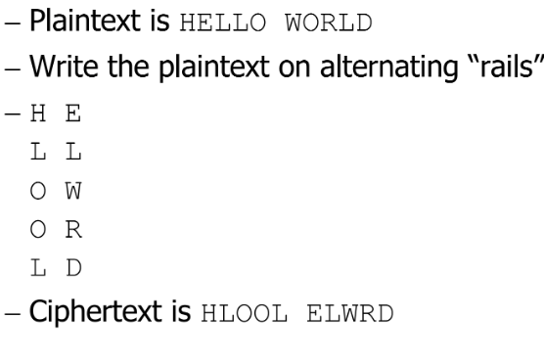
        + Attacking this cipher, we can use Angramming

If 1-gram frequencies match English Frequencies, but other n-gram frequencies do not, probably transposition

Rearrange letters to form n-grams with highest frequencies

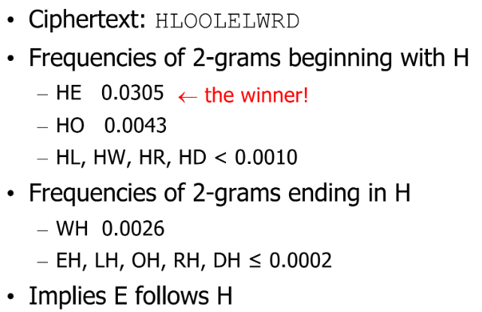

* + - Substitution Cipher
      * Changes characters in plaintext to produce ciphertext
      * Caesar Cipher
        + EX: If plainext is Hello World, change each letter to the third letter following (H becomes K, E becomes H, L becomes O, and so on). Ciphertext becomes KHOOR ZRUOG
        + 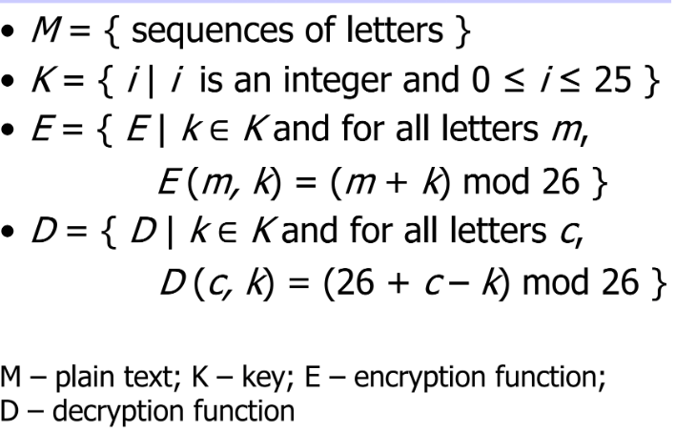
        + Attacking the Cipher

Exhaustive search (try all possible keys)

Statistical Analysis

Right key should let decrypted message match the 1-gram model of English

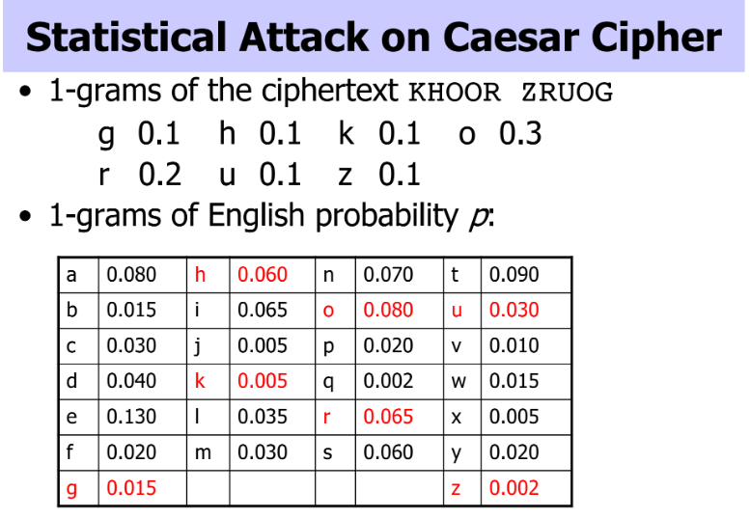

* + - * Vigenere Cipher
        + Like Caeser Cipher, but use a phrase as a key
        + 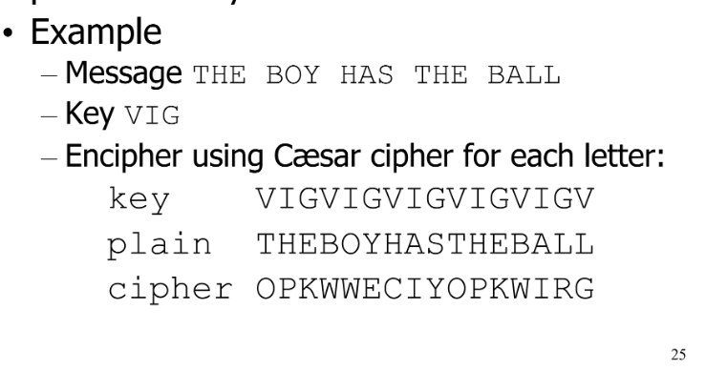
        + Terms

Period: Length of Key

Tableau: Table used to encipher and decipher

Polyalphabetic: Key has several different letters

* + - * + Attacks

Find repetitions in the ciphertext that occur when characters of the key appear over the same characters in the plaintext. Find all the ones that are probably not coincidences.

Index of Coincidence: The probability that any two randomly chosen letters from ciphertexts are the same.\

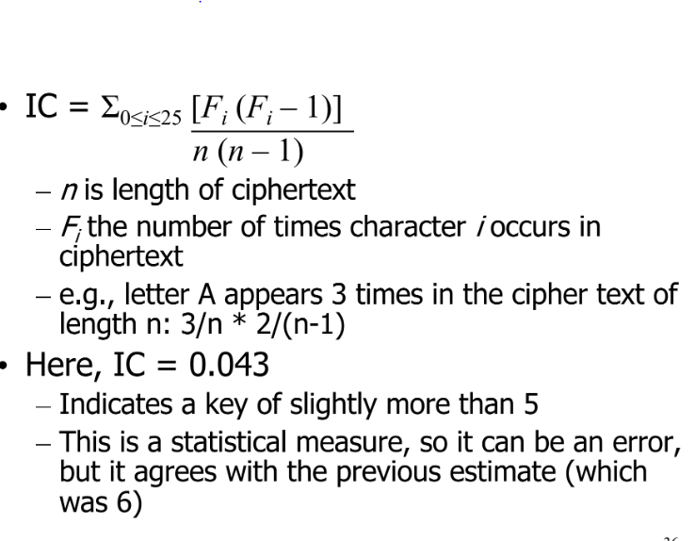

* + - * One-Time Pad
        + Vigenere Cipher with a random Key as long as the message
        + Probably Unbreakable

Equally likely to correspond to plaintext and any other 4 letters

Keys MUST be random

Key must be transmitted via a secure channel

* + - * Book Cipher
        + One-time pad with book text
        + Book text is not random, so can still perform language based statistical analysis
* **Symmetric Encryption**
  + **Block vs. Stream Ciphers**
    - Encipherment Function
      * Encipherment of message b with key k
      * In what follows, m = b1b2, each b of fixed length
    - Block Cipher
      * Ek(m) = Ek(b1)Ek(b2)
    - Stream Cipher
      * K = k1k2…
      * Ek(m) = Ek1(b1)Ek2(b2)....
      * If k1k2...repeats itself, cipher is periodic and the length of its period is one cycle of k1k2…
    - Examples
      * Vigenere Cipher
        + |bi| = 1 character, k = k1k2… where |ki| = 1 character
        + Each bi enciphered using ki mod length(k)
        + Stream Cipher
      * DES (Data Encryption Standard)
        + |bi| = 64 bits, |k| = 56 bits
        + Each bi enciphered separately using k
        + Block Cipher
    - Avalanche Effect
      * Key desirable property of an encryption algorithm
        + Change of one input or key bit results in changing approximately half of the output bits
      * If the change were small, this might provide a way to reduce the size of the key space to be searched
      * DES exhibits strong avalanche effect
    - Feistel Cipher
      * Design model from which may different block ciphers are derived
      * Encryption process uses Feistel Structure consisting multiple rounds of processing of the plaintext, each round consisting of a substitution step followed by a permutation step
      * 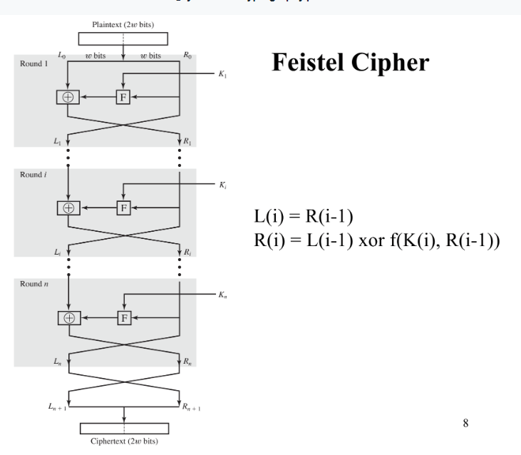
  + **DES**
    - Feistel Cipher with…
      * 64-bit block length
      * 56-bit key length
      * 16 rounds
      * 48 bits of key used each round (subkey)
      * Each round is simple, security depends heavily on S-boxes
      * 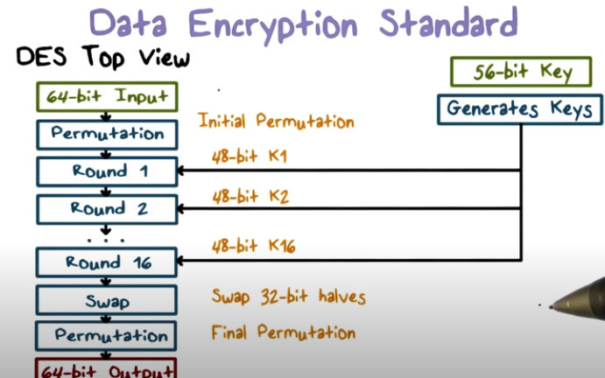
      * Each round of DES looks like below
      * 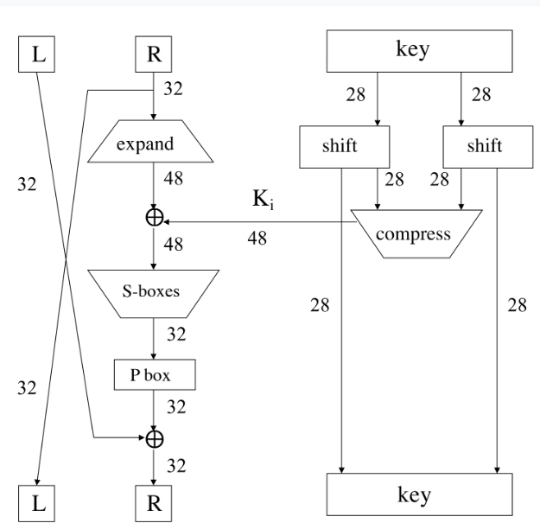
      * Expansion
        + 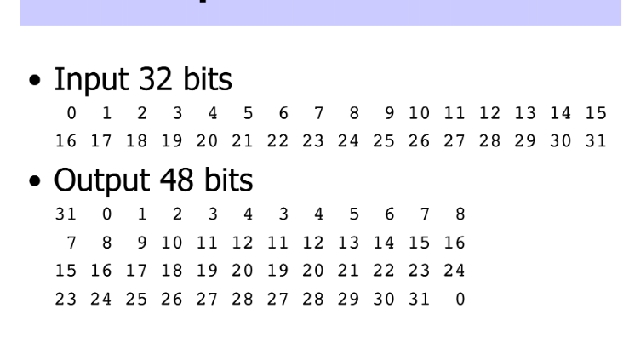
      * Substitution (s-boxes)
        + 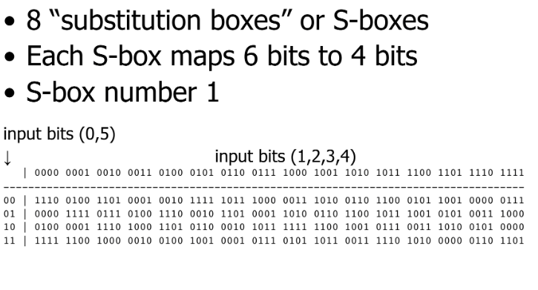
      * P-box
        + 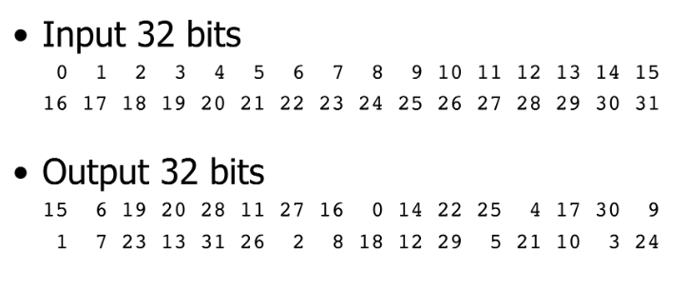
      * DES Subkey
        + 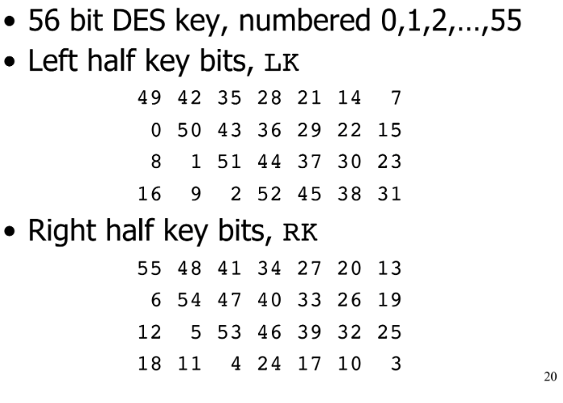
        + For rounds 1 through 16, the left half of the subkey is LK bits, and the right half of the subkey is RK bits.

For rounds 1, 2, 9, and 16, the shift ri is , and in all other rounds ri is 2

Bits 8, 17, 21, and 24 of LK are omitted each round, and Bits 6, 9, 14, and 25 of RK are omitted each round

Compression permutation yields a 48 bi subkey Ki from the 68 bits of LK and RK

Key schedule generates a subkey from this

* + - * More DES details
        + Initial permutation before round 1
        + Halves are swapped after the last round
        + Final permutation is applied to R16 and L16

None of this serves a security purpose

* + - * Security of DES
        + Security depends heavily on the substitution boxes

Everything else in DES is linear, Eight S-boxes which map 6 to 4 bits, and row selection depends on both data & key

* + - * + 30 years or analysis revealed no back door for attackers to use

Attacks use an exhaustive key search

* + - * Controversy
        + Considered too weak by some

Diffie Helman (1999) said in a few years tech would allow DES to be broken in days

Design decisions of DES not public

Design decisions underlying S-boxes (which may have back doors of their own) are unknown

Reduced key size from the original design plans

* + - * Double DES
        + With 56-bit keys, 2^56 possibilities, meaning a brute force attack is possible
        + Double encryption is not generally used

Susceptible to MTM attacks

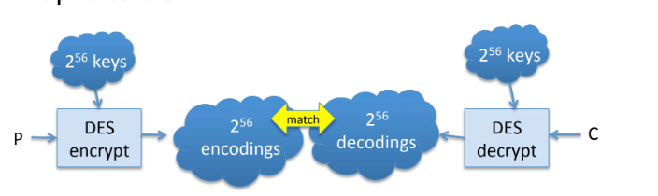

Makes brute force attacks more effective, requiring only 2^n+1 steps (instead of 2^2n steps))

* + - * Triple DES
        + 112 bit key
        + 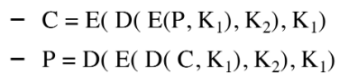
        + Not susceptible to MTM attacks
        + 112 bits is enough to dissuade brute force attacks
        + Most secure version of DES today
  + **AES**
    - Overview
      * An iterated block cipher, but not a Feistel cipher
      * Block size of 128 bits
      * Key length of 128, 192, or 256 bits (independent of block size)
      * # of rounds dependent on key length, typically 10 to 14
      * Each round uses 4 functions (processing the data as 4 groups of 4 bytes)
        + ByteSub

One s-Box used on every byte

* + - * + ShiftRow

Permute bytes between groups/columns

* + - * + MixColumn

Subs using Matrix Multiply of groups

* + - * + AddRoundKey

XOR state with key material

* + - * Each are implemented using XORs or Lookup Tables, making the algorithm extremely fast
    - ByteSub
      * Treats a 128-bit block as a 4x4 byte array
      * 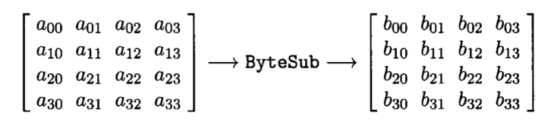
      * AES’s version of a S-box
        + 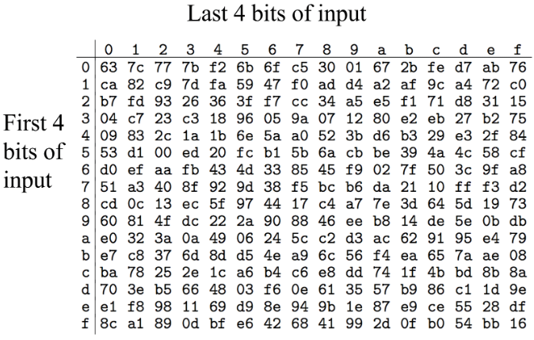
    - ShiftRow
      * Cyclic shift rows
      * 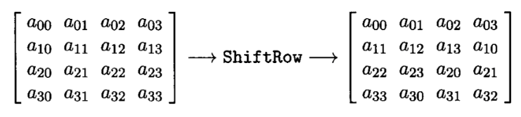
    - MixColumn
      * Invertible, Linear operation applied to each column
      * Implemented as a lookup table
      * 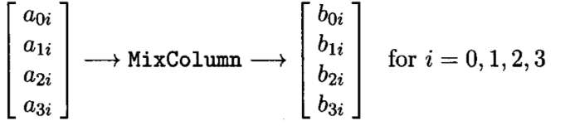
    - AddRoundKey
      * XOR subkey with a block
      * RoundKey determined by a key schedule algorithm
        + 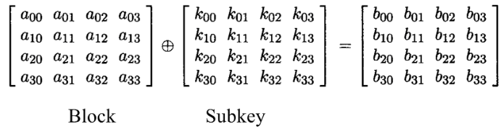
    - Visualization of AES Rounds
      * 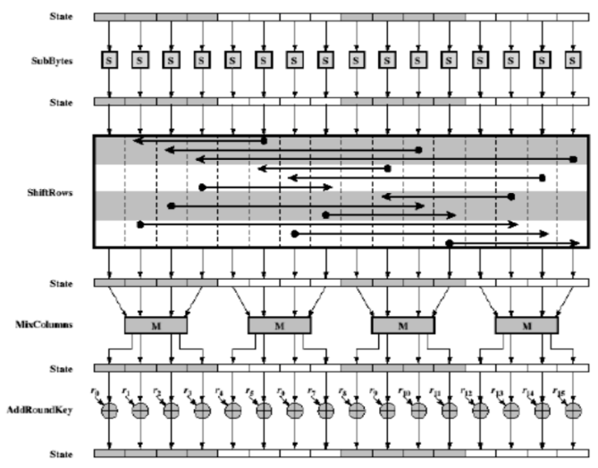
      * 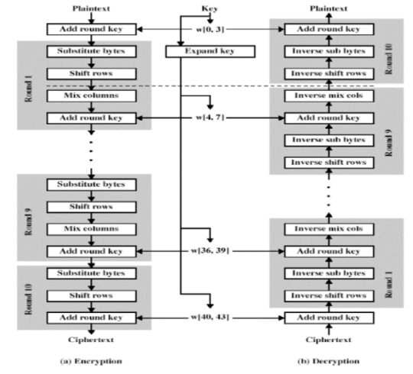
    - AES Decryption
      * Process must be invertible, but every step is easy to invert
        + AddRoundKey XOR is its inverse
        + MixColumn/ByteSub is invertible (implemented as a lookup table)
        + ShiftRow is a cyclic shift in the opposite direction\
    - Attacks on AES
      * Cryptanalysis has been successful, but not yet a practical concern
* **Block Encryption Modes**
  + **ECB**
    - Electronic Code Book Mode
      * Encipher, Decipher multiple bits at once
      * Each block enciphered independently
      * 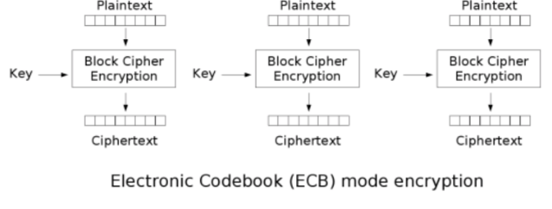
    - Problems with ECB
      * Identical plaintext blocks produce identical ciphertext blocks
        + 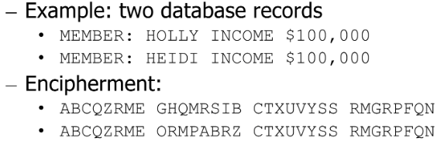
        + 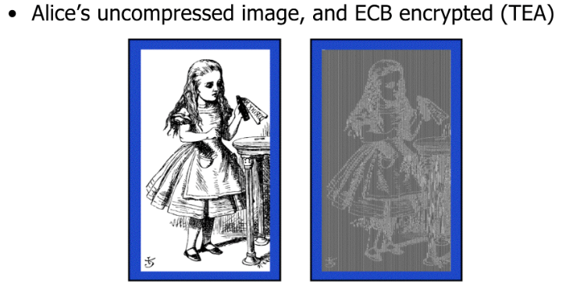
      * Need to insert info about the block’s position into plaintext, and then encipher it
        + We can use something the receiver knows and so can apply XOR in reverse when decoding
  + **CBC**
    - Cipher Block Chaining
      * Blocks are chained together
      * Random initialization vector (required to initialized CBC mode)
        + Random, but NOT secret
      * 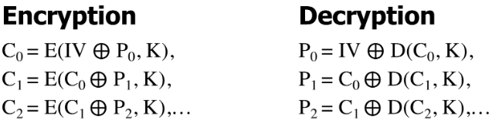
    - Encryption
      * 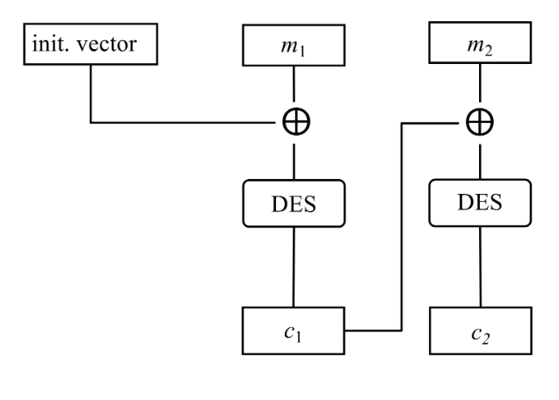
    - Decryption
      * 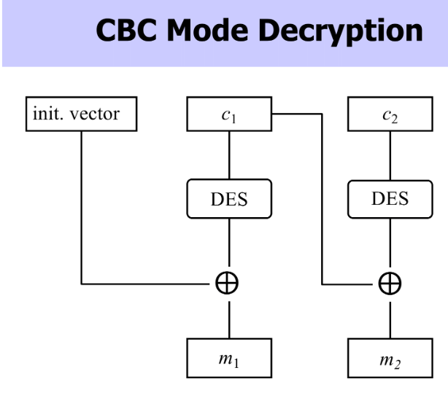
    - Pros and Cons
      * Identical plaintext blocks yield different ciphertext blocks
      * Automatically recovers from errors
      * Cut and paste is still possible, but more complex
      * 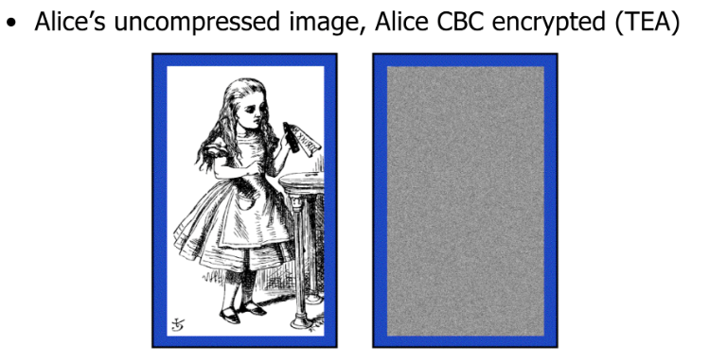
  + **Counter Mode**
    - Overview
      * Popular for random access
      * Uses a block cipher like a stream cipher
      * 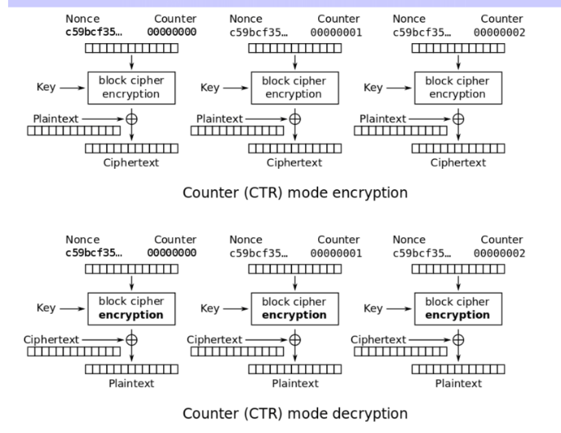
* **Public or Asymmetric Cryptography**
  + **General**
    - Symmetric Key Problems
      * Every pair of people must share a secret key
      * O(N^2) keys for N people
      * Must use a secure, out of band channel to exchange keys
    - Public Key overview
      * Two Keys:
        + Private key known only to the owner
        + Public key available to anyone
        + One key pair per person
        + Idea behind this

Gives all of CIA, while also giving symmetric key distribution

* + - * Based on “trap door one-way function”
        + Easy to compute in one direction, but hard to compute in other direction
      * Usage
        + Encryption

Can encrypt M with a public key

Can decrypt a private key to recover M

* + - * + Digital Signatures

Sign by encrypting with your private keys

Anyone can verify a signature by decrypting it with a public key, but only you could have signed

* + - * Pros/Cons
        + Much slower than symmetric key systems

RSA is 100 to 1000 times slower than DES

Generally used in conjunction with a symmetric system

* + - * + Based on Hard problems

Factoring large composites of primes, discrete log, elliptic curves

* + - Major Public Key Algorithms
      * 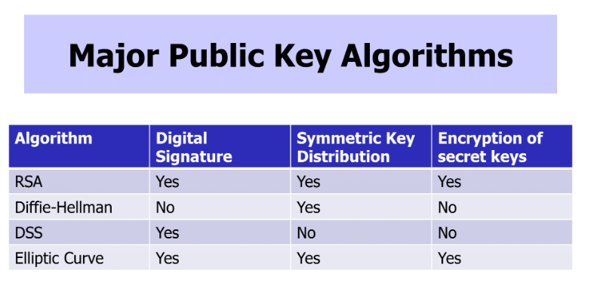
    - Diffie-Hellman
      * First public key cryptosystem proposed
      * 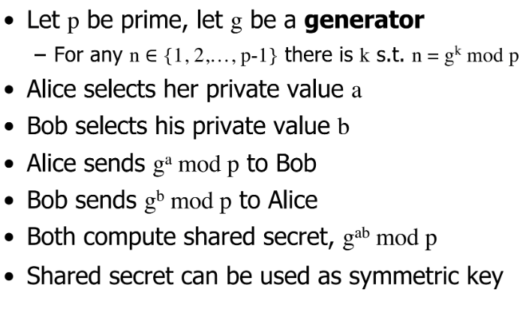
      * 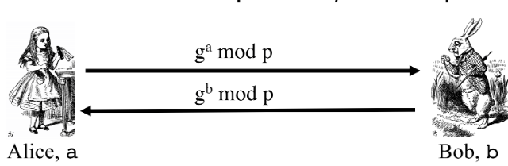
      * Subject to MTM
        + 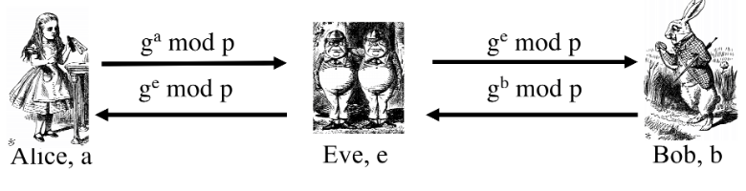
        + Preventable by encrypting DH exchange with symmetric key, and encrypting DH exchange with public key, as well as signing values
    - RSA
      * Let p and  be two large number, and N be p*q
        + E is (p-1)(q-1)
        + Find d such that ed=1(mod(p-1)(q-1))
        + Public key is (N, e)
        + Private key is d
      * If we treat message m as a number, to encrypt we compute
        + C = M^e mod N
        + M = C^d mod N
        + E and N are public

Factoring the modulus breaks RSA, since she can easily use e and N to find d

Factorization is difficult, but not impossible

Decades of experience has shown that it is very hard

Best known algorithm will have it factored in around 2 years, using distributed computing

* + - * Example
        + 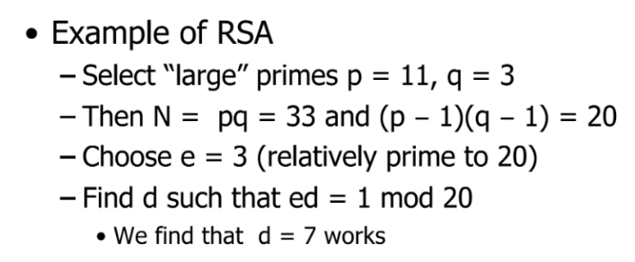
        + 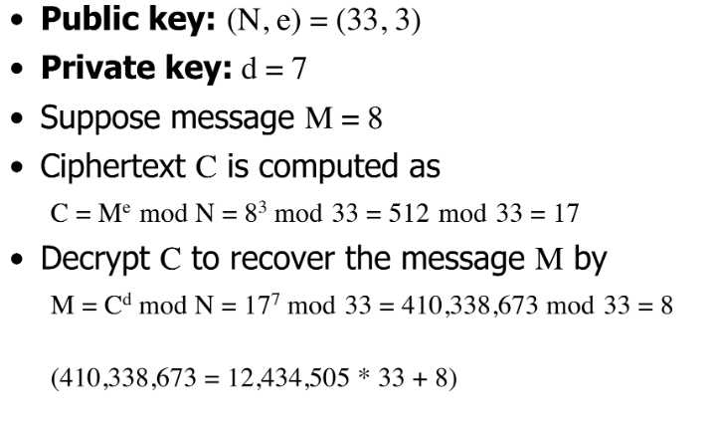
      * Warnings and Problems with RSA
        + Encipher messages considerably larger than in examples

If you only use 1 character per block, RSA can be broken in the same way classical cryptosystems can

* + - * + Can prove Non-repudiation

If A signs order with her private key, but A claims that she did not order, B can prove A placed an order

* + - * + Cannot prove Non-Non-Repudiation

If A signs an order with 100 stocks, and computes MAC with a symmetric key, B cannot prove that A did not order

* + - * + Paddings for RSA

Secret-key encryption uses encryption modes to encrypt plaintext longer than block size

* + - * + Attacks

Deterministic

Same plaintext encrypted using same public key gives same ciphertext

Secret key encryption can use a randomized IV to have different ciphertext

For small e and m

If m^e < modulus n, eth root of cipher text gives plaintext

* + - Sign and Encrypt vs. Encrypt and Sign
      * Order Matters
        + If you sign and encrypt, then pass the message along, others will think the message is from the original sender
        + If you encrypt then sign, others will think the message is from you (but it doesn't matter since the public key exists)
* **Crypto Hash**
  + **Difference from Regular Checksums**
    - Hashes are mathematical functions to generate a set of k bits from a set of n bits
      * EX: ASCII parity bit
        + ASCII has 7 bits, 8th bit is a parity

Even parity: even number of 1 bits

Odd parity: odd number of 1 bits

* + - * EX: 8 bit cyclic redundancy check
        + XOR all bytes in the file/message
        + Good for detecting accidental errors
        + Easy for malicious user to fix up to match altered message
    - Checksums are intended to verify the integrity of data, while hashes are designed to create a unique digital fingerprint of the data
      * Checksums protect against accidental changes, while hashes protect against attackers
      * Checksums are also called crypto hashes
    - If we say that h:X->Y
      * Preimage Resistant (one-way)
        + If given y { Y it is computationally infeasible to find a value x { X so that h(x) = y
      * 2nd preimage resistant
        + If given x { X it is computationally infeasible to find a value x’ { X s.t. x’ != x and h(x’) = h(x)
      * Collision resistant
        + If it is computationally infeasible to find two distinct values x’, x { X so that h(x’) = h(x)
  + **Keyed/Keyless and Standard Algorithms**
    - MAC
      * Hash to pass along with a message
      * Must be accessed with a key
        + Otherwise attacker could change MAC in transit
      * Proof of a message’s integrity
      * 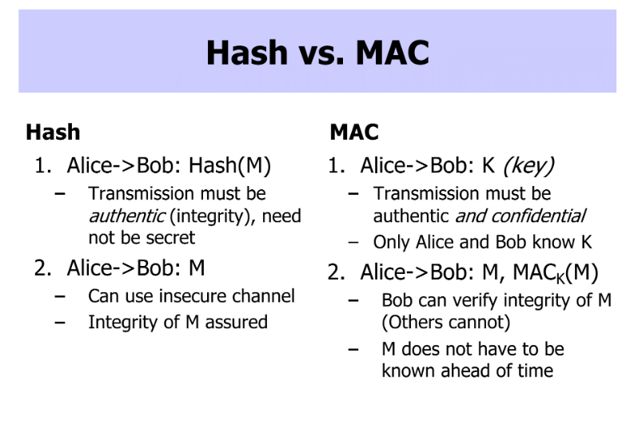
      * Network communication can encounter MTM attacks
        + Can intercept and modify data
        + Receiver needs to verify integrity of data
        + Attach tag to data

Using one-way hash as tag won’t work because MITM can recompute hash

Using a shared secret between sender and receiver in the hash

MITM cannot compute hash without secret key

* + - MD5/SHA
      * Keyless crypto hashes
      * Both are round based bit operation
        + Similar in spirit to AES and DES
      * MD5 is 128 bits and SHA-1 is 160 bit
      * Problem with MD5?
        + Only collision resistant to 2^64 bits
      * SHA
        + 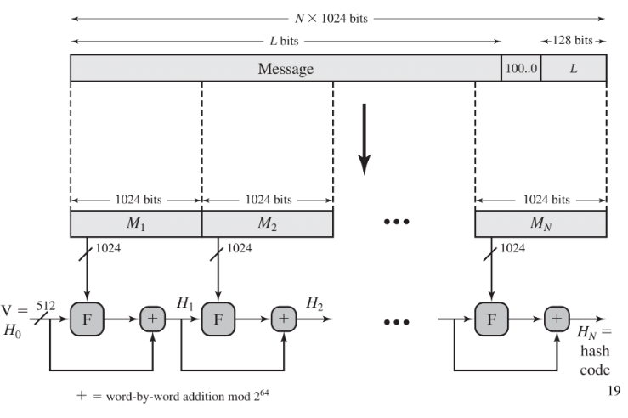
  + **Brute Force Attacks**
    - Attacking one-wayness
      * Given h:X->Y, y{Y, find x such that h(x) = y
      * Algorithm
        + Pick a random value x in X, check if h(x)=y, if h(x)=y, returns x. Otherwise iterate
        + After failing q iterations, return fail
      * Average case success is 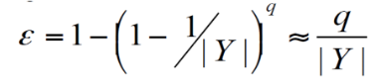
        + If |Y| = 2^m, then to get the probability to be 50%, q=2^m-1
  + **Birthday Attacks/Pigeonhole Principle**
    - If x != x’, and h(x) = h(x’), x and  x’ are a collision
      * Collision happens due to the pigeonhole principle
        + If there are n containers for n+1 objects, then at least one container will have 2 objects in it
        + If there are 32 files and 8 possible cryptographic checksum values, at least one value corresponds to at least 4 values
    - Birthday Attacks
      * Named after the Birthday Principle
      * Opponent generates 2^m/2 variations of a valid message all with essentially the same meaning
      * Opponent also generates 2^m/2 variations of a desired fraudulent message
      * Two sets of messages are compared to find pair with same hash
      * Have user sign the valid message, then substitute the forgery which will have a valid signature
      * Need to use larger MACS to get around this
  + **HMAC**
    - Can compute a MAC of the message M with key K, using a hashed MAC, or a HMAC
    - Keyed hash
    - Uses hash function H (compression function block size B) and a secret key K
      * Ipad = 0x36 (B times), opad = 0x5c (B times)
      * Can be used with any one-way hash function
      * 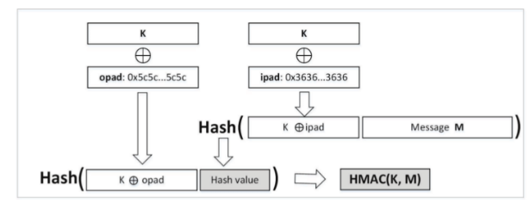
    - Birthday attacks don’t make sense in HMAC scenario, since attacker would need to know K to generate candidate message/hash pairs
* **Crypto Strengths**
  + **Brute-Force Key Search (symmetric algorithms)**
    - Attack Strength is O(size of key space)
    - Strength of AES-192 is O(2^192)
    - Some special cases, ex: double encryption and meet in the middle
  + **Attack Hard Problem (asymmetric algorithms)**
    - Know the hard problems underlying RSA and DH (see public cryptography)
    - Know how an easy solution to the hard algorithm breaks the cipher
  + **Crypto Hash**
    - Weak-Collision Resistance
      * Attacker wants to find malicious message that has same hash as OG message
      * Attack steps needed ~ O(2^n); n bit hash; assuming algorithm hasn’t been “broken”
      * Example: SHA-256 has 256 output bits so attack steps needed are around O(2^256)
    - Strong-Collision Resistance
      * Attacker wants to find two messages that have the same hash
      * Attack steps needed ~ O(2^n/2); n bit hash; birthday attack
  + Note: mostly put this section in because it was on the review, but most of this has been covered in sections prior to this one.
* **Identity and Key Management**
  + **Digital Signatures**
    - A wants B to know that he/she sent message M
      * Sends a digital signature along with the message
      * Need to figure out…
        + How B would verify the signature
        + Could C intercept and change M
        + How does B know that A is the sender
    - Bind identity to key
      * Classical infrastructure: Not possible as all keys are shared
        + Uses protocols to agree on a shared key
      * Public key: binds an identity to a public key
        + People will use key to communicate with principal whose identity is bound to key
        + Erroneous binding means no secrecy between principals
        + Assume principal identified by an acceptable name
  + **Long Lived vs. Session Keys**
    - Session Key: Encryption/decryption key that is randomly generated to ensure the security of a communications session between a user and another computer or between two computers
    - Long Lived Keys: Encryption/decryption key that is used past the session
  + **Randomness and pseudo random**
    - What is random?
      * Sequence of cryptographically random numbers: a sequence of numbers n1, n2, …. Such that for any integer k > 0, an observe cannot predict nk even if all of n1, … nk-1 are known
      * Best are physical sources of randomness (random pulses, natural phenomena, characteristics like disk latency, ambient background noise)
    - What is pseudorandom?
      * Sequence of cryptographically pseudorandom numbers: sequence of numbers intended to simulate a sequence of cryptographically random numbers but generated by an algorithm
      * Best algorithms
        + 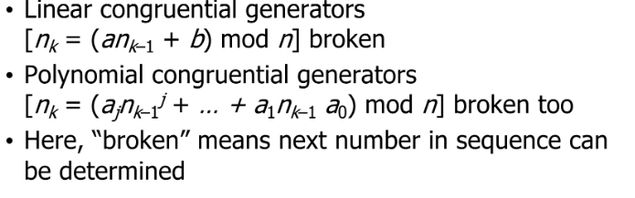
        + Strong mixing function: function of 2 or more inputs with each bit of output depending on some nonlinear function of all input bits

DES, MD5, SHA-1, etc.

* + **Key/identity Distribution**
    - B needs C’s public key to validate a certificate
      * Need a secure distribution of public keys
      * Solution: Public Key Infrastructure using trust anchors called Certificate Authorities
    - Needham-Schroeder
      * 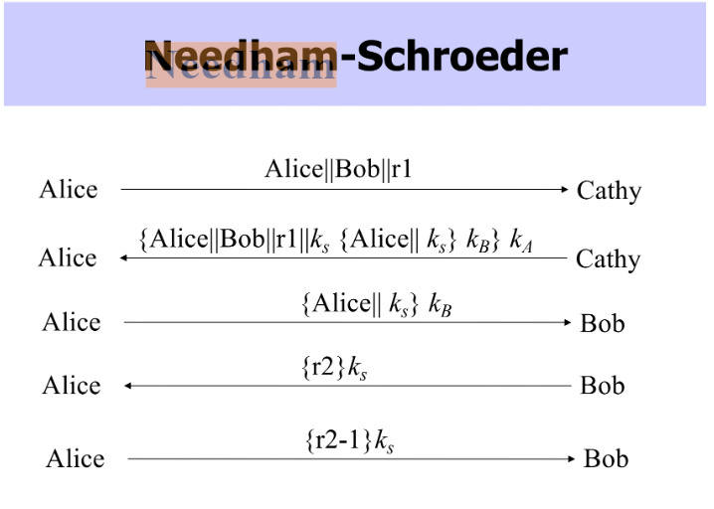
      * Fundamental basis for the Kerberos Protocol
        + 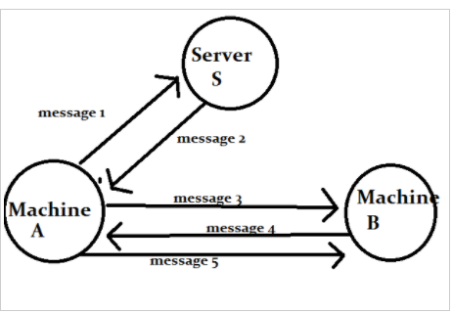
        + 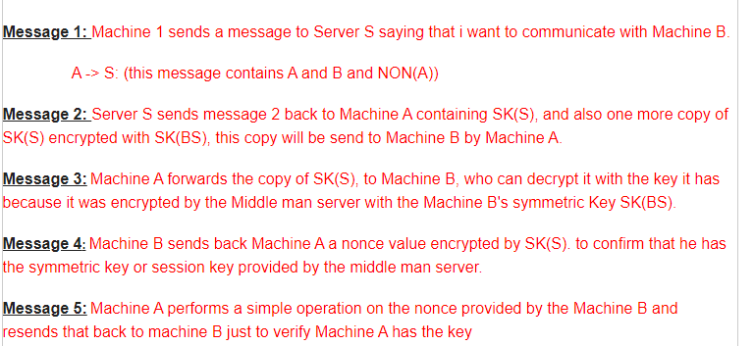
    - Kerberos
      * Basic steps to authenticate in a Kerberized Environment
        + Client requests an authentication ticket (TGT) from the Key Distribution Center
        + KDC verifies the credentials and sends back an encrypted TGT and session key
        + TGT is encrypted using the ticket granting service (TGS) secret key
        + Client stores the TGT and when it expires the local session manager will request another TGT
        + 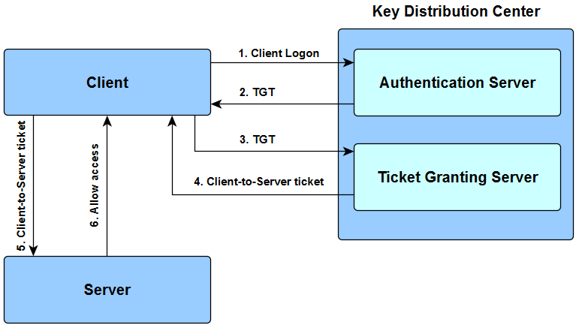
      * If a client requests access to a service or other resource on the network, this is the process…
        + Client sends current TGT to the TGS with the service principal name of the resource the client wants to access
        + KDC verifies the TGT
        + TGS sends a valid session key
        + Client forwards the session key to the service to prove the user has access
    - PKI Trust Models
      * Single global CA
        + Unmanageable, who is the universally trusted root?
      * Hierarchical CA
        + Tree of CA’s, but still needs to be rooted somewhere
      * Hierarchical CAs with cross-certification
        + Multiple root CAs that are cross-certified
        + Cross-certification at lower levels for efficiency
      * Web Model
        + Browsers come pre-configured with multiple trust anchor certificates
        + New Certificates can be added
      * Distributed
        + New CA; instead, users certify each other to build a web of trust
    - Cross Certifying
      * 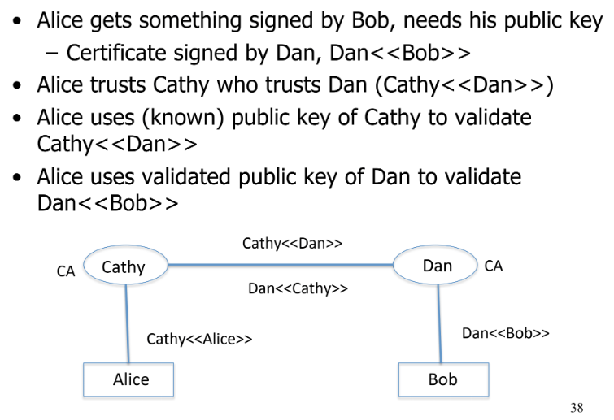
* **Authentication**
  + **Establishing IDs**
    - Authentication: binding of identity to subject
      * Identity is that of external entity (my identity, the IIT Galvin Library, etc.)
      * Subject is computer entity (process, network connection, etc.)
    - Two steps
      * Identification step: present identifier to security system, registration
      * Verification step: Present or generate authentication information that corroborates the binding between entity and identifier
    - How do we establish identity?
      * Need to know…
        + What the entity knows, has, is, does, and Where the entity is
  + **Spent a lot of time on passwords**
    - Password based Authentication
      * External entity is bound to a system ID
      * Authentication Step
        + External entity presents password
        + System compares with previously stored password
        + If password matches, system starts process with bound ID
        + Later access control decisions made against ID

Privilege decisions made against ID

* + - Vulnerabilities
      * 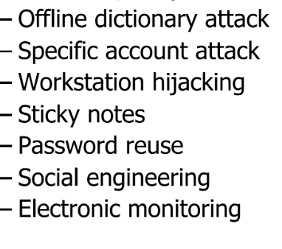
      * Preventing attacks
        + Hide info so that either authentication input, authentication functions, or stored verification info cannot be found. Prevents obvious attack from above
        + Block access to all verification methods

Prevents stacker from knowing if guess succeeded

* + - Storing passwords
      * Store as clear text
        + PW file compromised, so all passwords revealed
      * Encipher files
        + Decipherment/encipherment keys in memory
        + Reduce to previous problem
      * Store one-way hash of password
        + If the file is revealed, attackers must still guess passwords or invert the hash
    - Salt
      * Fixed length cryptographically-strong random value appended to passwords
      * Choose random salt s and compute y = h(pw, s) and store (s, y) in the password file
      * Salt is not a secret, easy to verify salted password
        + But an attacker must recompute dictionary hashes for each user, which is lots more work for an attacker
      * Have a set of n hash functions
        + Randomly select one function when registering new authentication info
        + Store ID of function with registered info
      * Attacker must try all n functions to see if the guess matches any password
  + **Challenge Response**
    - User and system share a secret function
    - User proves knowledge of secret function by answering a challenge
    - 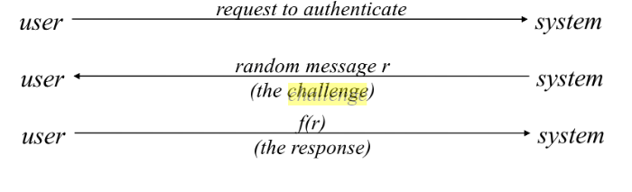
      * Mechanism for authentications; response is password for that particular number
  + **Biometrics**
    - Security processes that verify a user’s identity through unique biological traits, such as retinas, irises, voices, facial characteristics, and fingerprints
    - Advantages:
      * Identity Assurance
        + Convenient and more secure
      * Ease of Use
      * Good at Fraud detection
      * Could phase out passwords sometime in the future
* **SSL/IPSec**
  + **Comparison**
    - Networks Layers
      * Anything that has to do with the inter network connections takes place here. This last process is the most important as the vast majority of Internet traffic is sent over an IP
      * IPsec is a network level protocol
    - Authentication Methods
      * SSL begins with a handshake process to agree on which protocol to use. Once a secure connection is created, the next step is to exchange certificates and keys as needed.
      * IPsec is a network-level protocol that requires setup before on both servers and the client
    - Performance
      * SSL is faster, but IPsec setup in Transport mode is close in speed
    - Transparency
      * IPSec is fully transparent, but SSL is not.
      * SSL is not a permanent connection, and can be terminated easily. IPSec requires specialized hardware and software, so it’s harder
  + **Handshake Protocol**
    - Basics
      * Used to initiate connection
        + Sets up parameters for record protocol
        + 4 rounds
      * Upper layer protocol
        + Invokes record protocol
    - Phase 1 and 2
      * 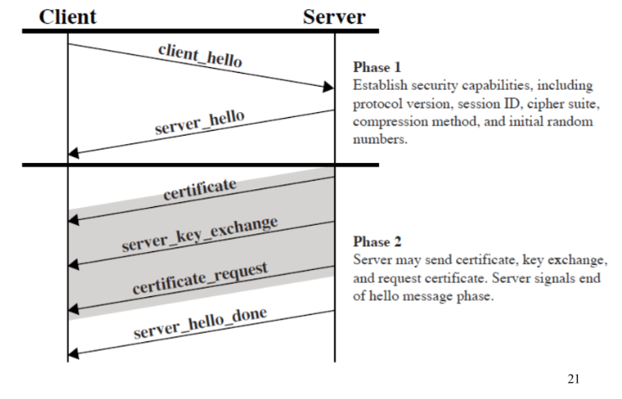
      * 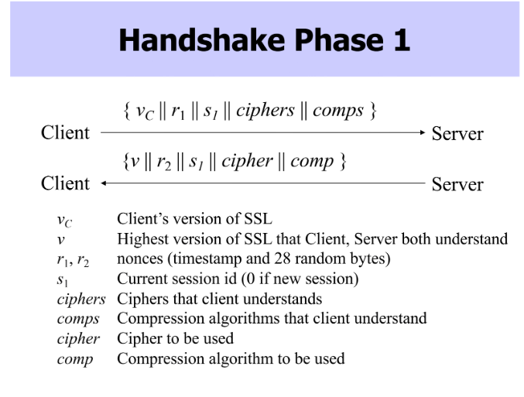
      * 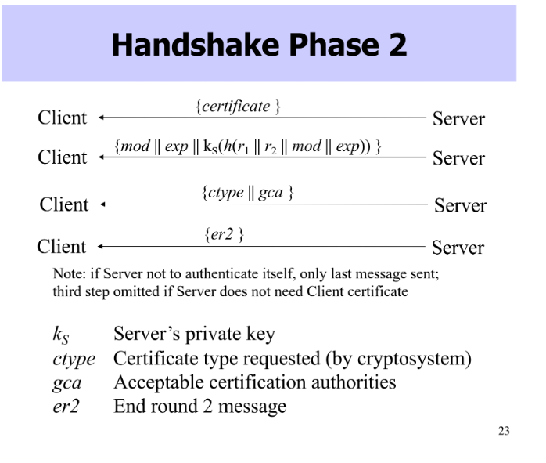
    - Phase 3 and 4
      * 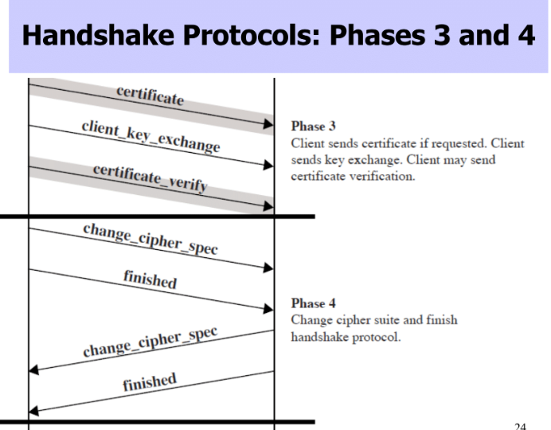
      * 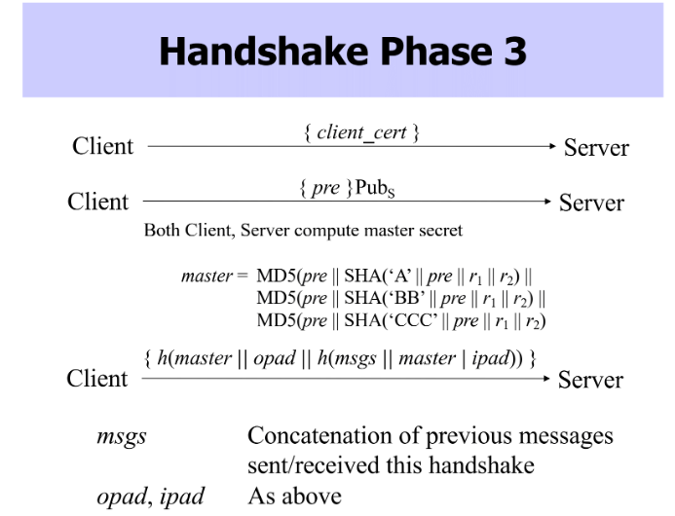
      * 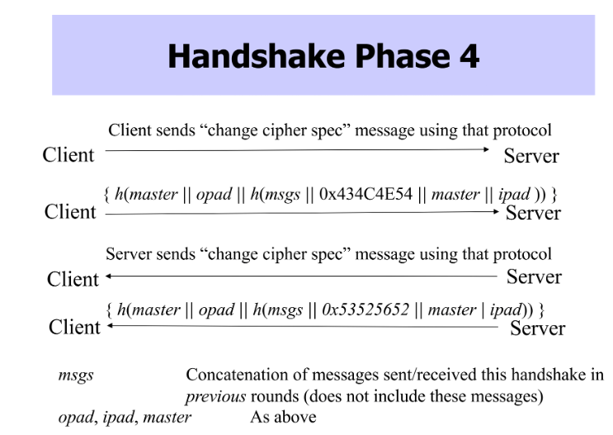
  + **IPSec**
    - Network layer security
      * Provides confidentiality, integrity, authentication of endpoints, and replay detection
        + Protects all messages sent along a path
    - Tunnel Mode
      * 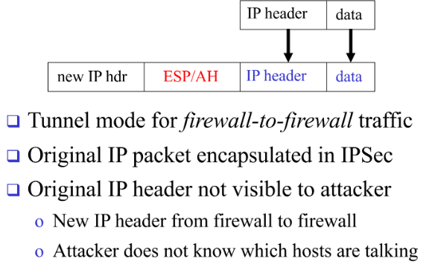
    - Firewall-to-Firewall
      * 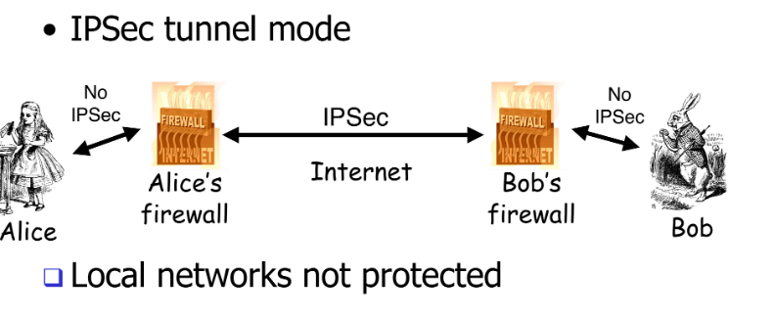
    - 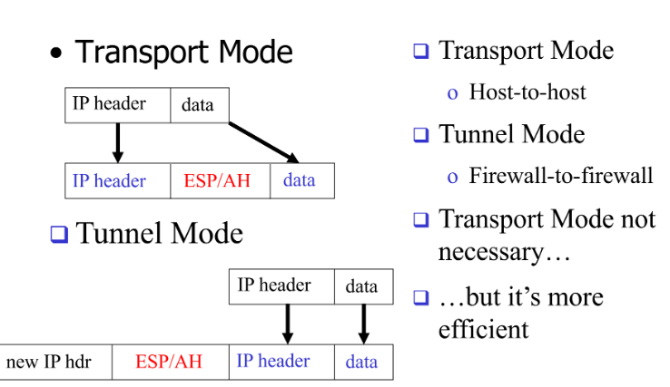
* **Access Control**
  + **AAA**
    - Authentication
      * Determine whether access is allowed.
      * Authenticate human to machine or machine to machine.
    - Authorization
      * Once you have access, what can you do?
      * Enforces limit on actions
      * Also called “Access Control”
    - Audit
      * Review of system actions
  + **DAC/MAC/RBAC**
    - Discretionary Access Control
      * Decisions made based on identity of requestor and access rules.
      * Regular users can adjust the policy.
    - Mandatory Access Control
      * Decision made by testing labels associated with processes and resources against system policy rules.
      * Regular users **cannot** adjust the policy.
    - Role Based
      * Access decisions defined against roles rather than individual requestors.
  + **Access Control Requirements**
    - Reliable Input
    - Fine and coarse grain specs
    - Least Privilege provision to accomplish a task
    - Separation of Duty → More than one entity to complete a task to manage conflict of interest
    - “Open” Policy → Access limitations are specified, all others allowed
    - “Closed” Policy → Access limited to those explicitly stated.
  + **Access Matrix**
    - Lampson’s Access Control Matrix  
      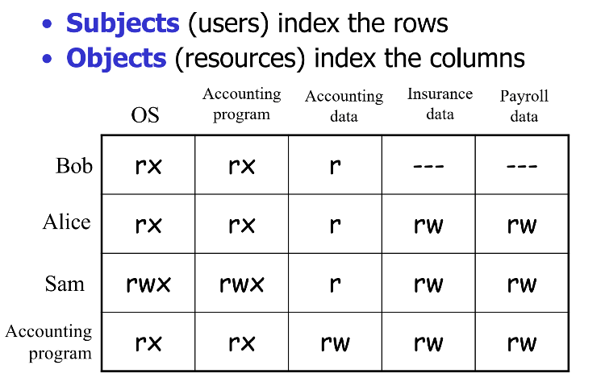
    - r-> read; w->write, x->execute
    - Slice by Column [**Access Control List]**
      * Store Identity of entities that are permitted access to the objects
      * Used by most modern OSs
    - Slice by Row [**Capability List**]
      * Store identity of objects a subject may access with the subjects.
  + **Access Control Lists**
    - 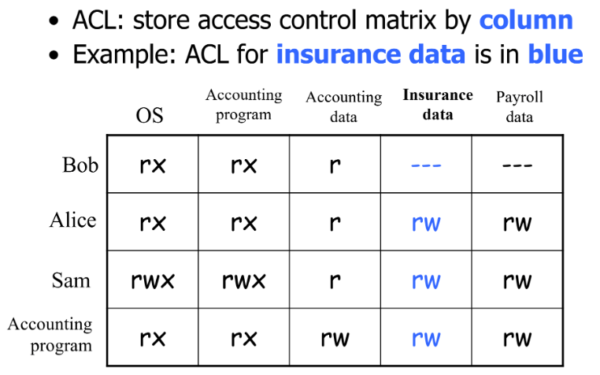
  + **Capabilities**
    - 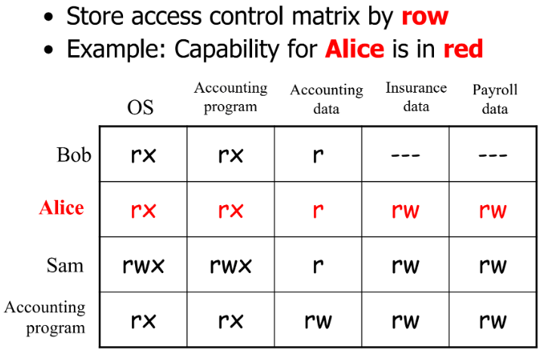
* **RBAC**
  + **Add Intermediate Role Layer (And basics of RABC)**
    - Components
      * User
        + Assigned with one or more roles based on qualifications

Can be reassigned with different roles

* + - * + Operations

Execution of a program specific function that is invoked by a user

* + - * + Objects

Entity that contains or receives info that has exhaustible system resources

Disk Space, OS Files, DB Columns/Rows, etc.

* + - * + Map users to roles
        + Users take on more than one role during sessions
      * Role
        + Organization job function with a clear definition of inherent responsibility and authority

The relation between users and permissions

* + - * + Each role is defined by a set of permissions
        + Roles are created for job functions in an organization
        + Role represents competency and authority
        + Roles can be granted new permissions for new apps
        + Permission can be revoked from a role, if the system changes
        + Map roles to permissions
      * Permission
        + Association between an operation and an object

Object method pair

Table query pair

* + - * + Permission Assignments to Objects

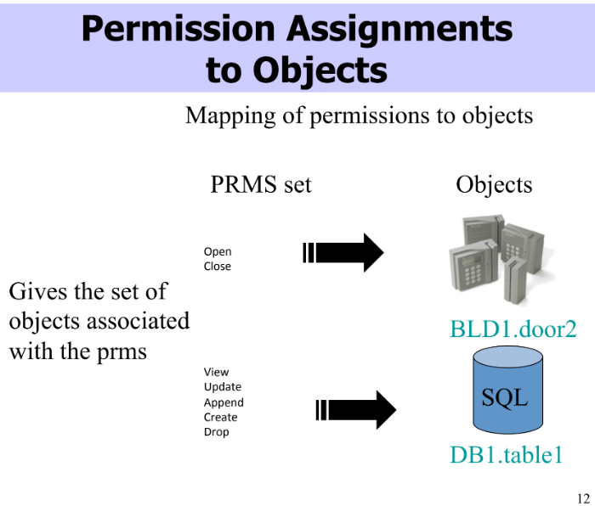

* + - * + Permission Assignments to Roles

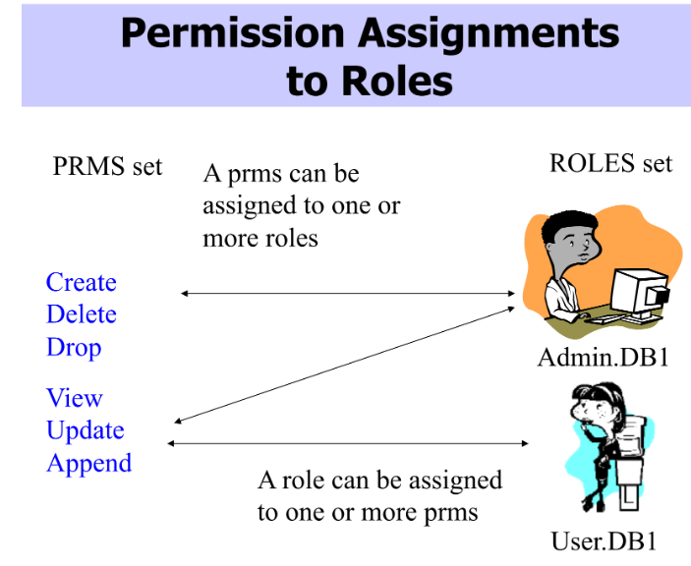

* + - * + User Assignments

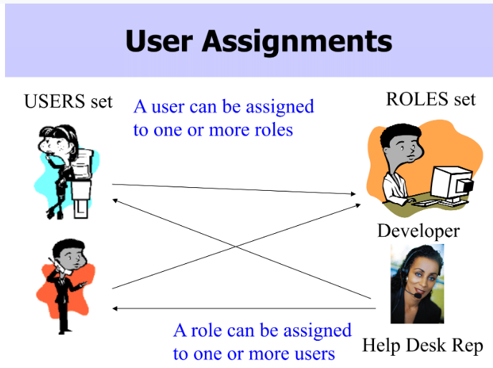

* + - * + Example:

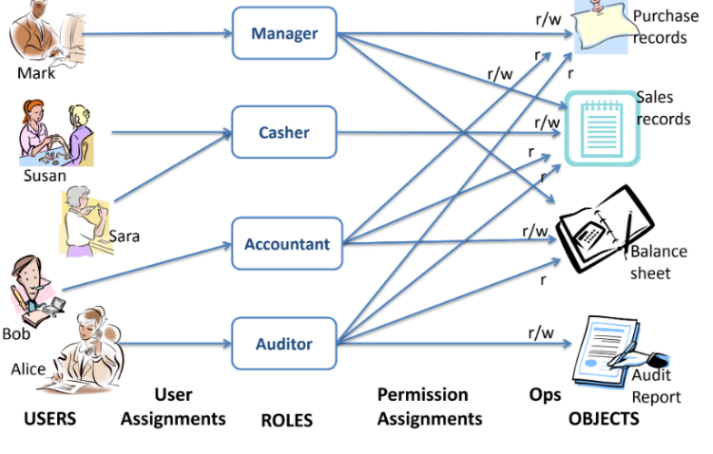

* + - General Principles
      * Design of security systems/mechanisms need to follow some important principles:
        + Least Privilege

RBAC can be configured so only those permissions required for tasks conducted by members of the role are assigned to role

* + - * + Separation of duties

By ensuring that mutually exclusive roles must be invoked to complete a sensitive task

* + - * + Simplicity of mechanism

RBAC is simple

* + - * + Completeness and correctness

RBAC policy verification helps with this

* + **Models of RBAC**
    - RBAC0
      * 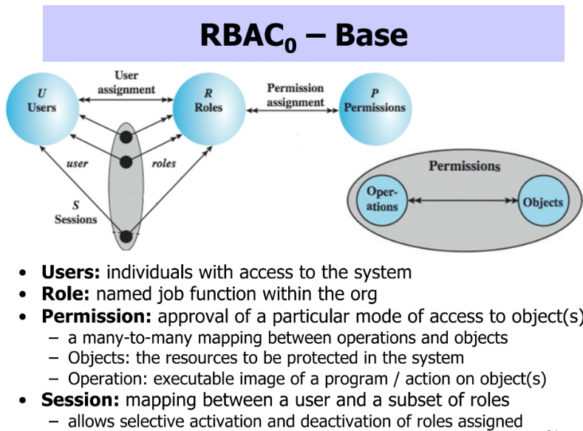
      * Base Model
    - RBAC1
      * 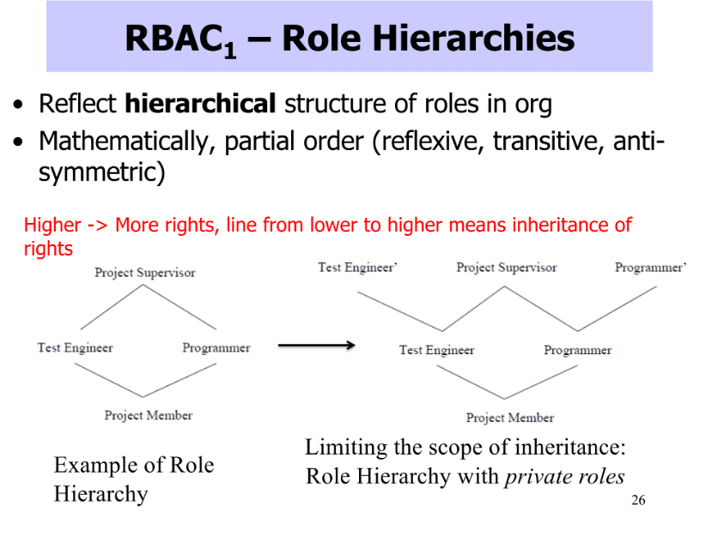
      * Adds Hierarchy to RBAC0
    - RBAC2
      * 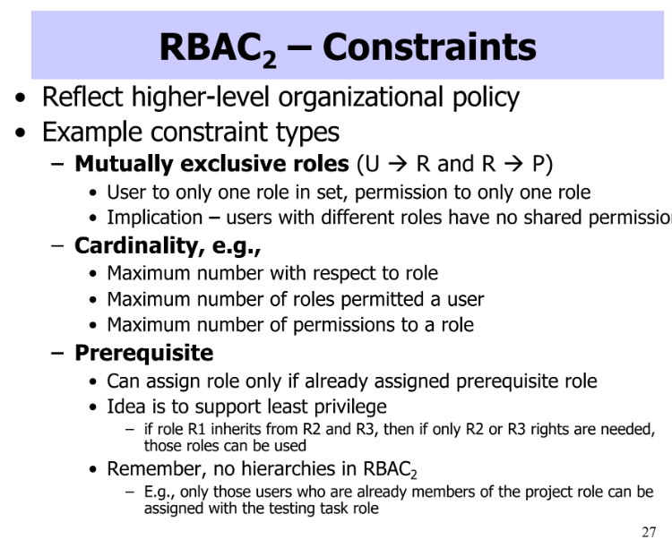
      * RBAC0 + Constraints
    - RBAC3
      * 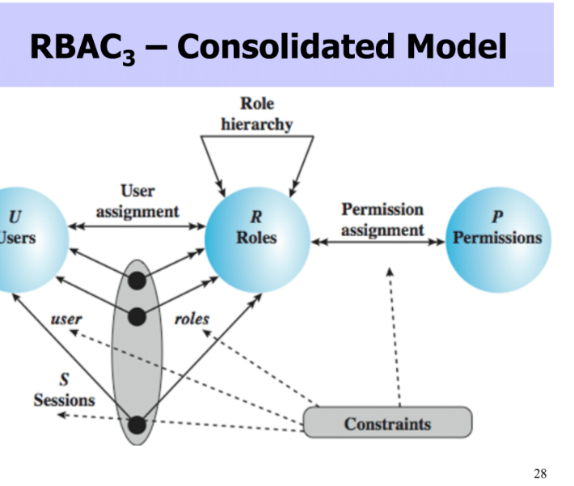
      * Both RBAC1 and RBAC2 (constraints and hierarchy)
  + **NIST Standard**
    - Components
      * Core
      * Hierarchical RBAC
        + Limited Hierarchies
        + General Hierarchies
      * Constrained RBAC
        + RBAC w/ Static separations (with and without hierarchies)
        + RBAC w/ Dynamic separation
        + RBAC w/ general constraints on attributes of users/objects/environment
    - Constraints
      * SSD
        + Prevents conflict of interest
        + Cardinality constraint on a set of roles
        + Mutual exclusive roles as a special case

SSD := ({r1,r2}, 2)

* + - * DSD
        + Similar to SSD, but activated within sessions

Typically for temporal conflicts of interest

Def

(role set,n) (n≥2) no **user session** may activate ≥nroles from role set

* **Mandatory Access Controls**
  + Def
    - Access Decisions cannot be changed by normal rules
    - Generally enforced by a system wide set of rules
    - Normal user cannot change access control schema
  + MLS (multilevel security)
    - Needed when subject/objects at different levels use/on same system
    - Below are MLS models
  + **Bell-LaPadula Confidentiality Model**
    - Security model designed to express essential requirements for MLS
      * Deals with confidentiality (to prevent unauthorized reading)
    - IF O is an object, and S is a subject, O has a classification, S has a clearance, and security level denoted by L(O) and L(S)
    - Model Consists of…
      * Simple Security Condition:
        + S can read O IFF L(O) <= L(S)
      * *-Property:
        + S can write O IFF L(S) <= L(O)
      * No Read up
        + Subject can only read an object of less or equal security level
        + L(O) <= L(S)
      * No Write Down
        + * property
        + A subject can only write into an object of greater or equal security level
    - DAC in MAC
      * DS-property
      * MAC system may also include traditional discretionary access control check
        + IF * and simple security checks pass, also check discretionary access rules
    - Comparing Security Labels
      * 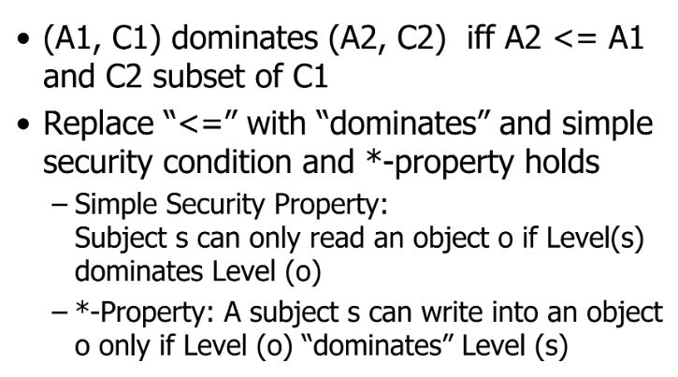
    - Inspired other security models
      * Most try to be more realistic/complex
  + **Biba Integrity Model**
    - More focused on integrity
      * Prevent unauthorized writing
      * Dual of a Biba
    - Integrity model
      * 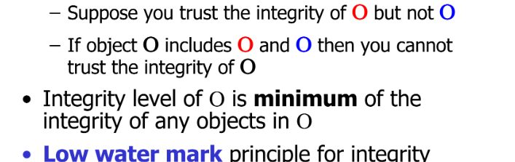
      * 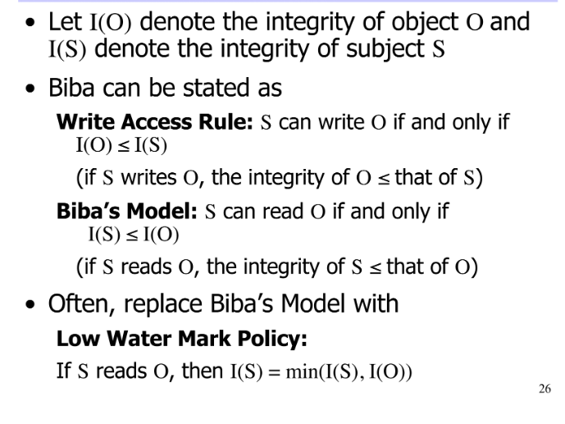
    - BLP vs. BIBA
      * 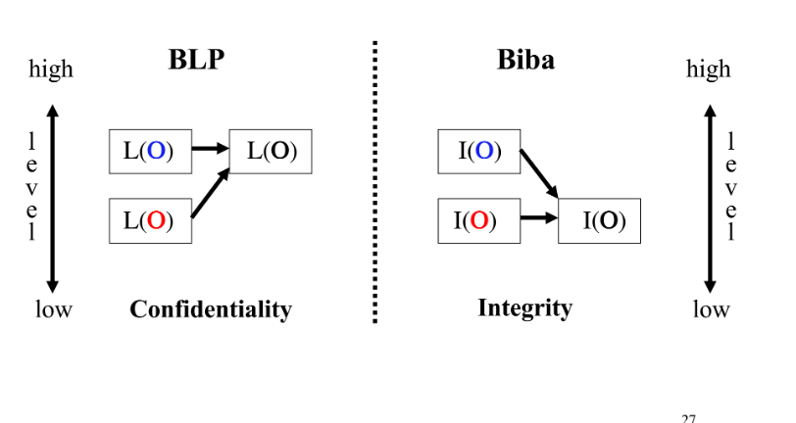
  + **Chinese Wall Model**
    - Addresses enforcing conflict of interest policies
      * If consultant knows sensitive info about A, and also works with B (competitor to A), consultant shouldn't access info about B
    - Defs
      * Subjects: Active entities
      * Info
        + Objects
        + Dataset: All objects that concern the same corporation
        + Conflict of interest class: all data sets whose corporations are in competition
      * Access rules: rules for r/w access
    - SS rule
      * S can read on O only if/or
        + O is in same dataset as object already accessed by S
        + O belongs to CI from which S has not yet accessed any info
    - * property rule
      * Subject S can write object O only if
        + S can read O according to SS rule AND
        + All objects that S can read are in the same dataset as O
  + 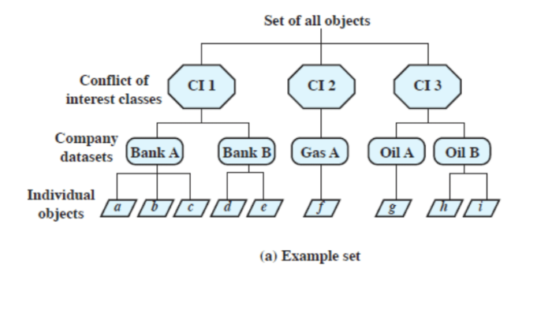
* **Database Security**
  + **Access Control Model**
    - Relational Model
      * Info stored in relations/Tables
        + Each row is a tuple of attributes
        + Manipulated by an SQL language
      * Combining tables
        + Can use Join to create a single set of tuples
      * Making Queries
        + Can select to create sub-tables---
    - Access Control
      * Dont have a single owner of all the data
        + Create new table
        + Use grant to give others privileges on table
      * Can create views to have finer granularity with access control
      * Can delegate privilege granting authority to others
      * SQL Grant
        + 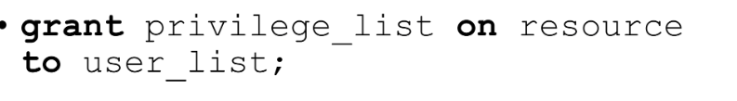
        + 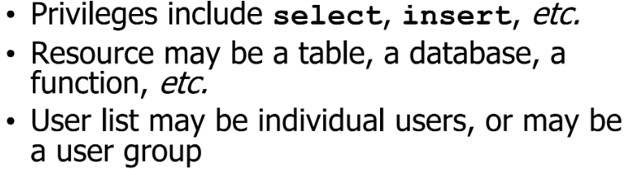
      * Creating Views
        + Subset of the database which user has access
        + 
      * Row Level
        + 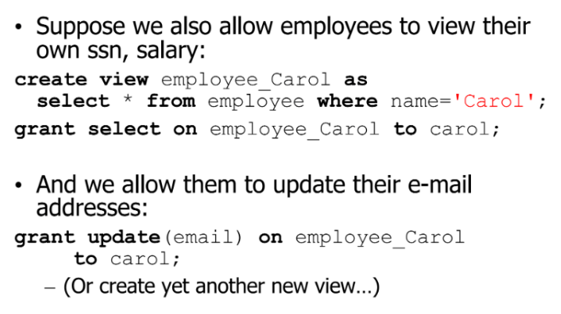
      * Delegating Policy Authority
        + 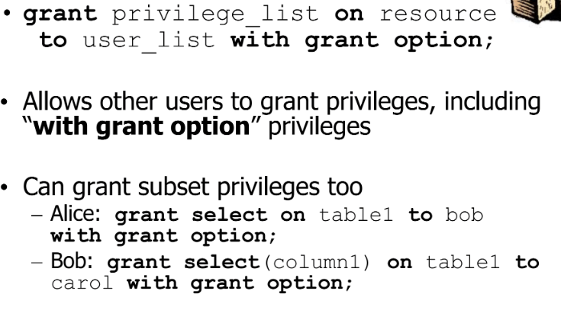
      * Revoke
        + 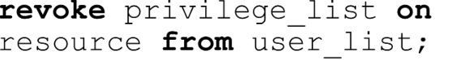
      * Disadvantages of SQL Model
        + Too many Views to create
        + No obvious way to see that the views come from the same table
  + **Statistical Databases**
    - Provides a statistical data (counts and averages)
    - Comes up in two contexts:
      * Pure statistical DB
        + Only statistical info
      * General DB, with statistical functions (our focus)
        + Provide aggregate data without compromising confidentiality of data
    - Protections
      * Will often refuse to answer to queries if the number of records involved are too small
    - Query Size Restriction
      * 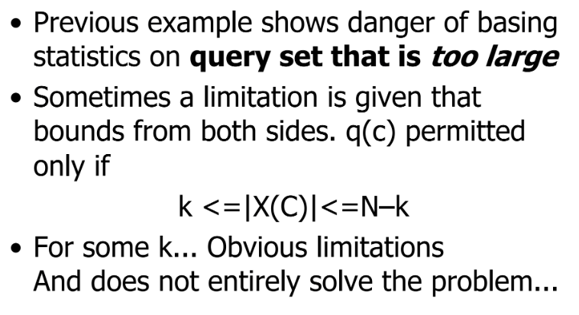
    - Tracker Attack
      * System refuses to answer
        + 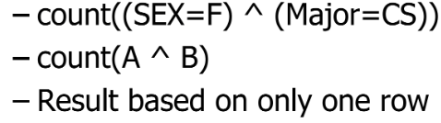
      * Break into multiple queries
        + Count(A)-count(A^!(B))
      * Can generalize this approach to solve for linear systems of queries
  + **SQL Injection Attack**
    - 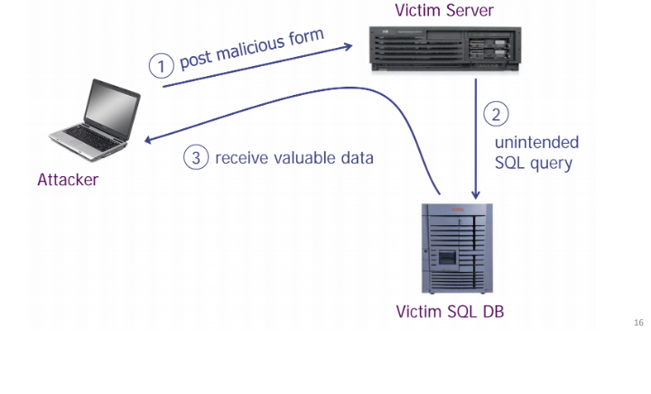
    - Launching SQL Injection Attacks
      * 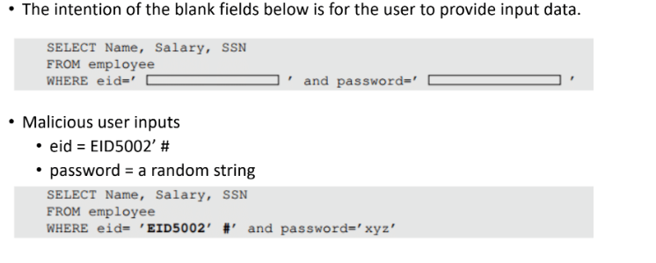
      * 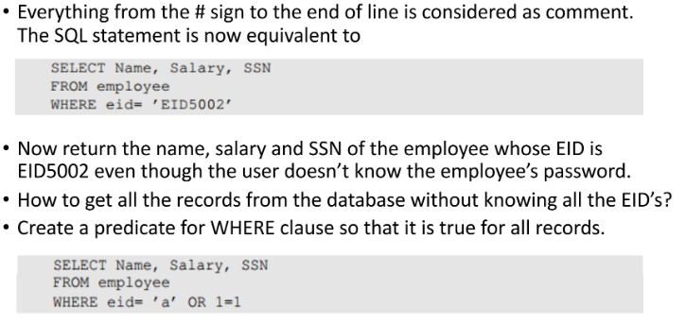
* **Malicious Code**
  + **Types of Malicious Code**
    - Trojans
      * Unexpected functionalities
      * Seemingly useful program that contains code that does harmful things
        + Both overt and covert actions
        + Logins, spoof authentication/webpage forms, embedded in games/email attachments
        + Ex: Disguise an mp3 as an application that has the same level of permissions that the user does
    - Rootkits
      * Hook standard OS calls to hide data
      * Replace function table entries
        + New version performs extra checks to hide info before performing original call
        + For masking malware payloads more effectively
        + Can replace Windows API pointers
        + Can also replace syscall table pointers
      * Require privilege
        + Most windows installs also require privilege anyway
      * 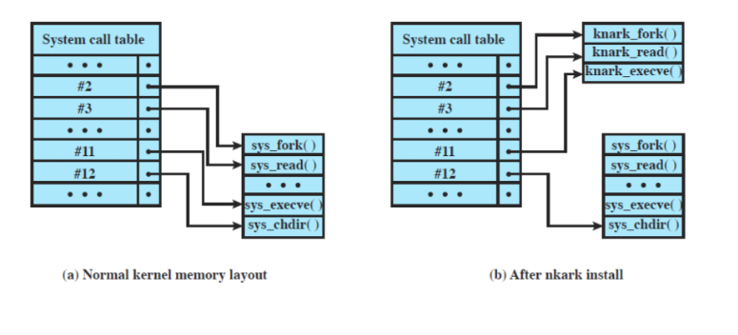
    - Viruses
      * Passive Propagation
      * Infection mechanism
        + How the virus moves from victim to victim
      * Trigger
        + Condition that causes payload to activate
      * Payload
        + Activity of the virus beyond the spreading
      * Operation
        + Phases

Dormant: Waiting on trigger event

Propagation: Replicating to programs/disks

Triggering: By event to execute payload

Execution: Execute payload

Details are OS specific

* + - * Macro Viruses
        + Code attached to some data file

Interpreted rather than compiled

* + - * + Interpreted by a program using said file

Word, Excel, Auto command macros

* + - * + Blurs distinction between data and program files, making detection hard
    - Worms
      * Active Propagation
        + Self Propagating code, standalone software
        + Spread by exploiting flaws
        + Choose IP addresses, attempt to find vulnerable hosts
        + Look around local area for hosts with vulnerabilities

Attach to files/removable storage and go phishing

* + - * Morris Worm
        + Determine where it could spread, then spread its infection and remained undiscovered
        + Creator claimed his worm had a bug

Tried to reinfect infected systems, which led to resource exhaustion

* + - * + Spread by password guessing and exploiting buffer overflow and trapdoor
        + Once worm got access, bootstrap loader was sent to a victim, which compiled and executed code
        + If transmission interrupted code deleted

Code encrypted when downloaded, deleted after decrypt/compile

* + - * Penetration
        + Auto-exec on USB sticks
        + Buffer overflows in internet services and Applications
        + Lack of checking inputs/SQL databases
        + Humans use computers
      * Phases
        + 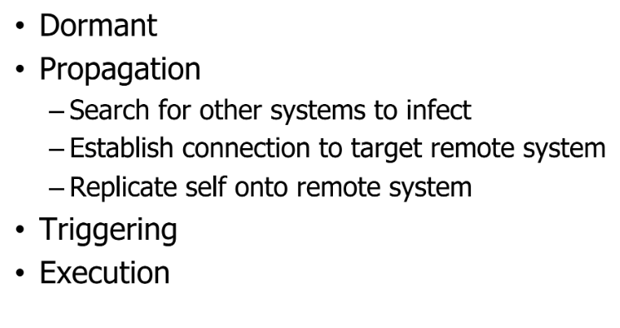
    - Botnets
      * Network of infested machines
        + Infested machines are bots

Victim is unaware of infection

* + - * + Uses IRC and p2p botnet architecture
      * Used for span, Dos attacks, keylogging, ID theft, etc.
      * Opportunity for Cyber-criminals
        + Keep the compromises quiet: they are assets
        + Put compromised machines under centralized control
        + Use the robot network for financial gain
      * Use for Spam, DDoS attacks
      * Even when found, shutting down botnets are difficult to shut down
        + Can be moved very rapidly
        + P2P can have no centralized controller, and all the attacker needs is a connection to the botnet
  + **Propagation Techniques vs. Hiding Techniques**
    - Zero Day Exploit
      * Exploit that has no patch available
      * Time between exploit discovery and activation is shrinking
      * Malware developer has a trade off:
        + Big splash but faster discovery
        + Reduced Attack rate but longer undiscovered
    - Avoiding Signature Scanning
      * Polymorphic Virus
        + Produces varying but operationally equivalent copies of itself
      * Stealth Virus
        + Actively tries to hide all signs of its presence
      * Encrypted Virus
        + Stores a bulk of itself self encrypted
      * Metamorphic virus
        + Mutates with each infection
        + Similar to polymorphic
    - Hit list
      * Reduces slow start up phase and gets off the ground fast
        + Pre select 10000 - 50000 vulnerable machines

First worm carries the entire hit list and begins scanning down the list

List split in half on each infection

Communicate half to recipient worm, keeping other half

* + - * + Get hit list by using Distributed Scanning, stealthy scans, DNS searchers, Spiders, surveys, or P2P
      * Scanning + Hit list can be very effective
    - 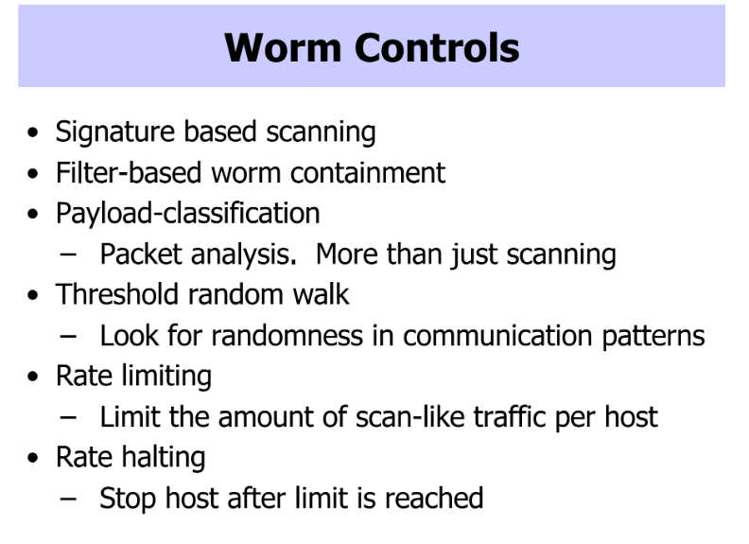
  + **Defenses**
    - Rootkit
      * Look for Discrepancies in User mode
        + EX: results of different apis and storage results
      * Naturally hard to defend/detect against
    - Virus Precautions/Signature Scanning
      * Don’t import untrusted programs
        + Install anti-virus which is updated regularly
      * Signature Scanning
        + Early viruses had characteristic code patterns (signatures)
        + Create database of patterns and search files for patterns (McAfee)

Can also use data mining to look for disguised and obfuscated patterns

* + - * Other Virus scanners
        + Can use heuristics/integrity checks rather than direct signatures
        + Can also track viruses by actions rather than code
    - IPv6
      * Hybrid viruses and pure worms change a lot in IPv6
        + Since address spaces are much larger, it's much harder to find viable targets
        + Dissuades random method of selection
* **Buffer Overflow**
  + Def
    - Condition at interface under which more input can be placed into a buffer or data holding area than the capacity allocated, overwriting other info
    - Possible attack scenario
      * 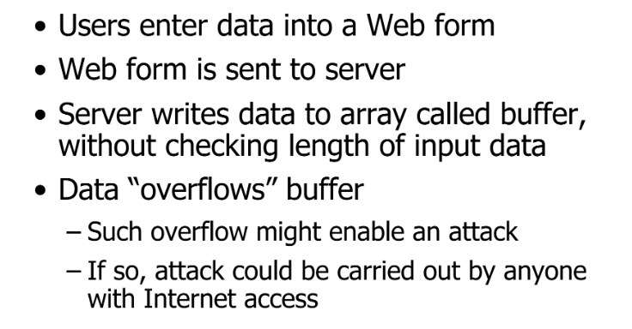
  + **Stack Overflow**
    - 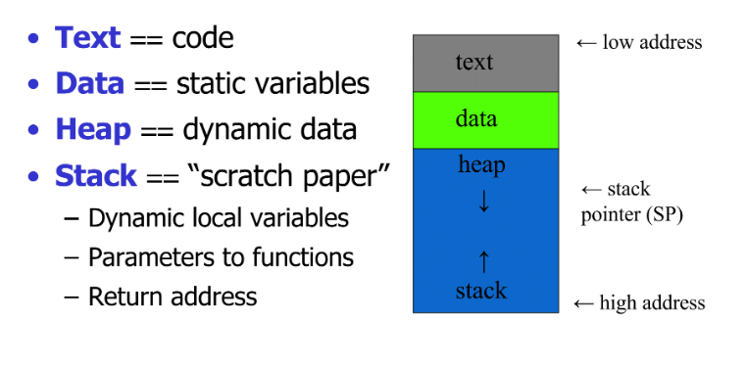
    - 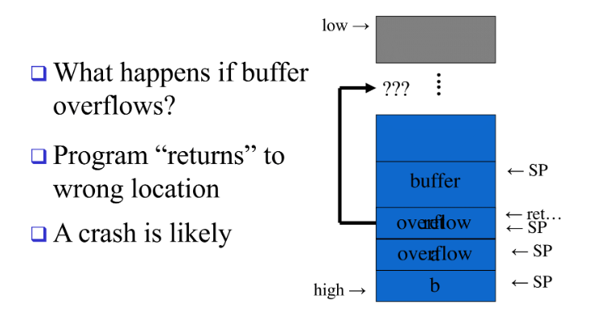
    - Attackers can use this to do some code injection
      * Can run code of his/her choice on your machine, while not knowing the address of the evil code or the location of the ret on the stack
        + Precede the evil code with a NOP and insert ret many times
    - Can set the return address to point to the custom code held within the stack frame
  + **Shell Code**
    - Want to transfer execution of program to code stored in the buffer we overflow
    - Called so because it launches a shell
      * Can run any program with privilege of an exploited program
    - 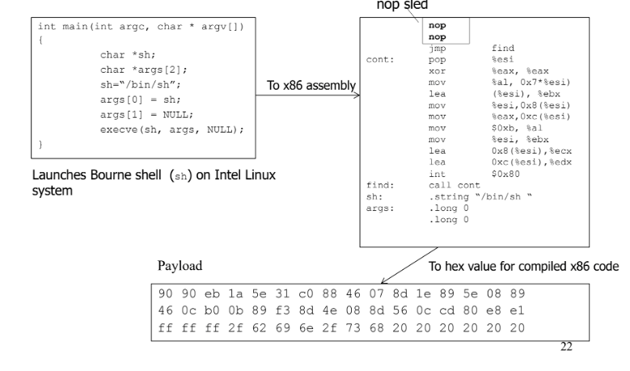
    - Targets programs with elevate privileges and vulnerable buffers
    - Needs to be position-independent
      * All addressing relative to self
      * Attack code doesn’t know exactly where the attack is in memory to know what jump address to place in the overflow
    - 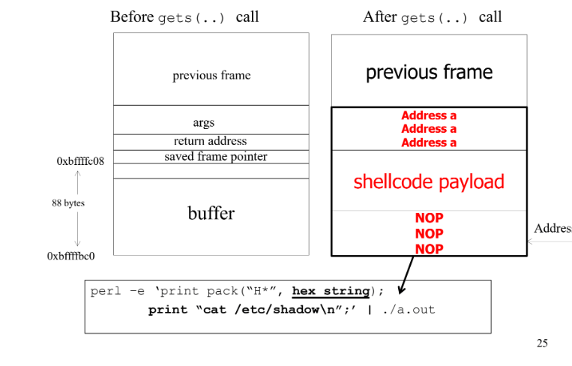
      * Now, can open and display contents of etc/shadow by sending the shell the cat command using root privilege
    - NOP sled
      * Sequence of NOP instructions meant to slide the cpu’s instruction execution flow to its final desired destination whenever the program branches to a memory address anywhere on the slide
      * 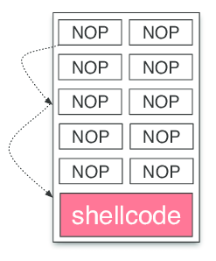
  + **Defenses**
    - Compile Time
      * Programming Language Choice
        + Use high level, not as vulnerable languages

Uses more resources

* + - * Extensions/Safe Libraries
        + Replace standard library routines with safer versions

Rewrite source with new calls

Strlcpy

Replace whole library provides protection w/o recompilation

* + - * Stack Protection
        + Check for Stack Frame corruption
        + Stack guard

Canary value

Included in new gcc

* + - * + Return Address Defender

Copy return address

Safe location

* + - Run Time
      * Executable Address Space Protection
        + Block execution of code on stack
        + No execute bit
        + Assume executable code held elsewhere
        + 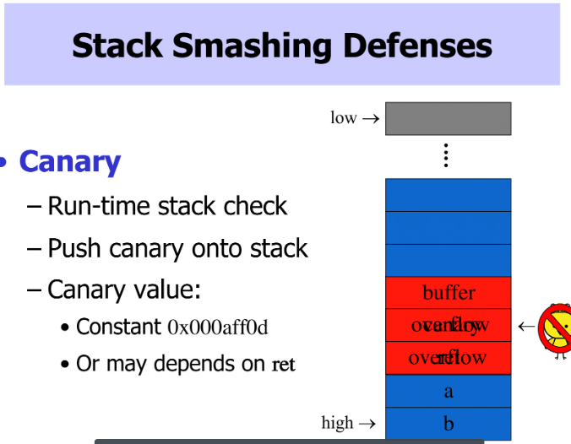
      * Address Space Randomization
        + Stack buffer overflow: need to predict address of buffer in memory
        + Change address stack location random per process
        + Address range is large, providing much variation. Larger than most vulnerable buffers
        + Therefore NOP-sled wont work
        + ASLR

Randomize place where code loaded in memory

Makes most buffer overflow attacks up to chance

* **Network Security**
  + **Denial of Service Attacks**
    - Occurs when legitimate users are unable to access info systems, devices, or other network resources due to the actions of malicious cyber threat actors.
      * Service affected may include email, websites, online accounts, or other services that rely on the affected computer/network
      * Accomplished by flooding the targeted host or network with traffic until the target cannot respond or simply crashes
        + Can cost organizations time and money while resources are inaccessible
    - Basic case
      * Use simple flooding pings
        + Higher capacity link floods lower capacity link
        + Easily traceable
    - Distributed case
      * Malware installed on many computers
      * Command and control system direct many bots to flood common target
    - Distributed case 2
      * Get many people to use their own computers to flood a common target
  + **Address Spoofing**
    - Senders can put any source address in packets they send
      * Can directly attack targets in a less traceable fashion
      * Can be used to send unwelcome return traffic to the spoofed address
      * Can be used to bypass filters to get unwelcome traffic to the destination
    - Routers can catch spoofers
      * Reverse path verification
      * Egress filtering
  + **ARP cache poisoning**
    - ARP
      * Used to discover mapping of neighboring ethernet MAC to IP addresses
        + Need to find MAC for 192.168.1.3 (in your interface’s subnetwork)
        + Broadcast an ARP request on the link
        + Receive ARP reply with correct MAC
        + Device stores this info in an ARP cache
      * 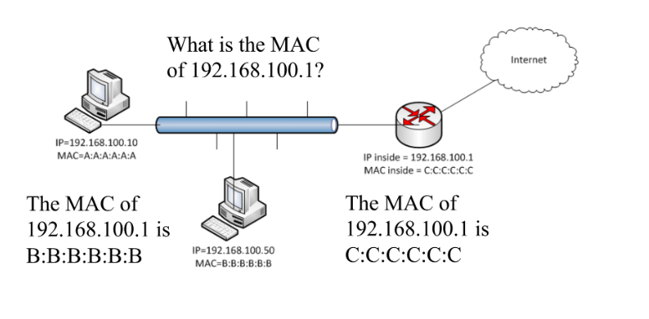
    - Cache Poisoning
      * Bootstrap problem with respect to security
      * A MTM attack
        + Send ARP reply messages to device so they think your machine is someone else
        + Better than simple sniffing because not just the best effort
      * Solutions to cache poisoning?
        + Encrypt all traffic
        + Monitoring programs (arpwatch) to detect mapping changes
  + **Smurf**
    - Internet Control Message Protocol
      * Used for Diagnostics
        + Destination unreachable
        + Time Exceeded
        + Parameter problem, bad header field
        + Source quench, throttling mechanism rarely used
        + Redirect, feedback on potential bad route
        + Echo request and Echo reply, ping
        + Timestep request and Timestep reply, performance ping
        + Packet too big
      * Can use info to help map out a network
        + Some people block ICMP from outside domain
    - Smurf Attacks
      * Amplification DoS attacks
        + Relatively small amount of info sent is expanded to a large amount of data
      * Send ICMP echo request to IP broadcast addresses
        + Spoof victim’s address as the source
      * Echo request receivers dutifully send echo replies to the victim overwhelming it
      * 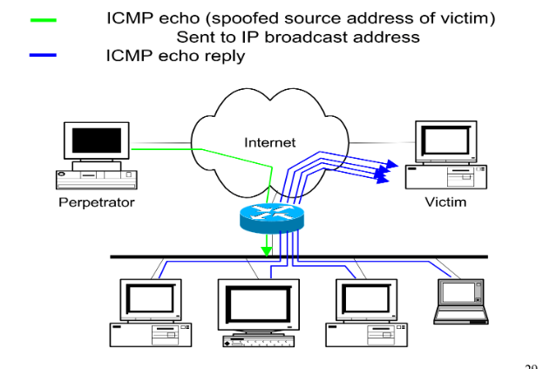
      * Reflector Attacks
        + Attacker sends packets to some non-hostile intermediate entity
  + **Open Relay DNS**
    - DNS
      * Hierarchical service to resolve domain names to IP addresses
        + Name space divided into non-overlapping zones
      * Can have primary and secondary DNS servers per zone. Use TCP=based zone transfer to keep up to date
      * No security designed in
        + DNS server is not automatically discovered
        + Info can be dynamically set via DHCP
    - Example of transaction
      * 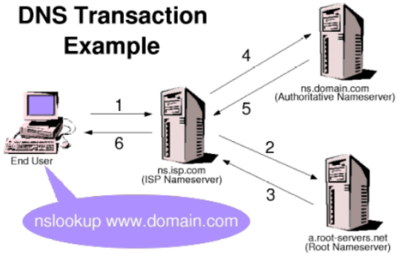
    - Communication
      * UDP
      * Requests and responses have matching 16-bit transaction IDs
      * Servers can be configured as
        + Authoritative Name Server

Answering requests for a domain

* + - * + Recursive

Pass on requests to other authoritative servers

* + - * + Both
    - Open DNS
      * Dns that will accept recursive queries from external locations
      * Enables amplification DoS attack
    - Open Relay
      * 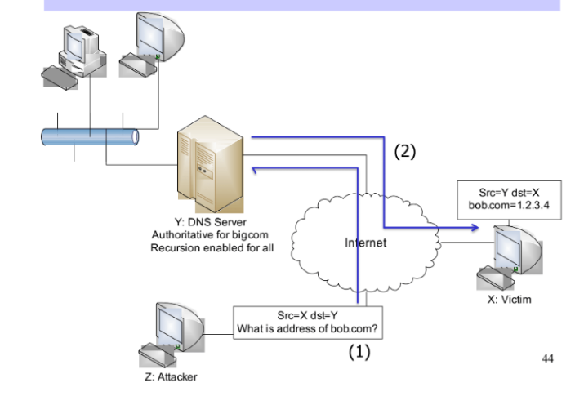
  + **DNS Cache Poisoning**
    - Older Implementations
      * Accept additional info in a reply
        + EX: false authoritative name server
        + Fixed by bailiwick checks
    - Bailiwick checks
      * 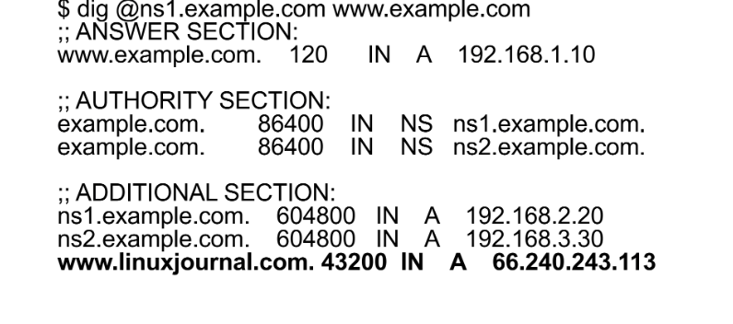
    - Newer Implementations
      * Spoof a reply must anticipate the correct transaction ID
        + Only 16 bits
        + Random selection of ID isn’t great
      * Most implementation don’t randomize source ports
      * Try to poison through the additional info
        + 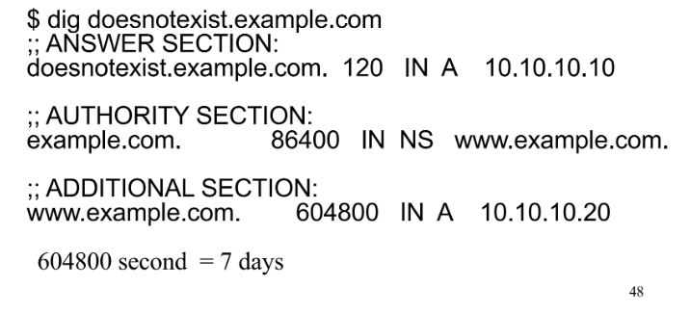
        + 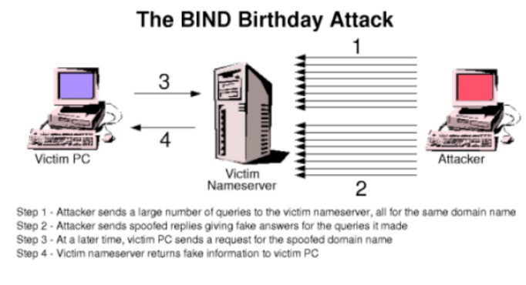
  + **TCP-Based Attacks**
    - Syn Spoofing/Flood
      * 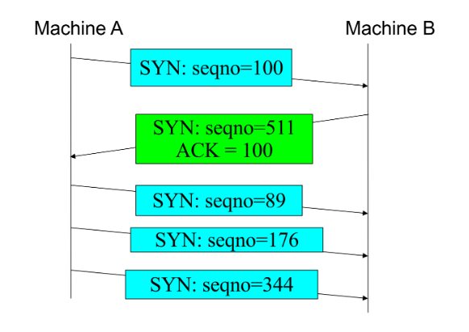
    - Reset
      * To disconnect a TCP connection....
        + A sends out a Fin packet to B
        + B replies with an ack packet. This closes the A-to-B communication
        + B sends a FIN packet to A and A replies with Ack
      * Using Reset Flag
        + One of the parties sends RST packet to immediately break the connection
      * 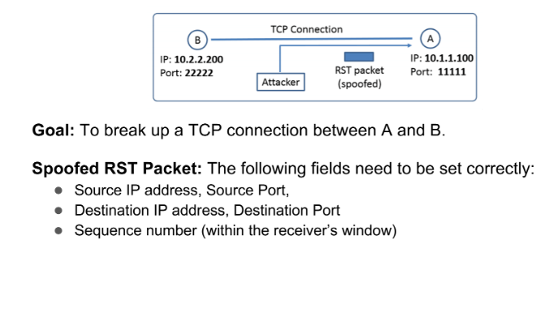
      * 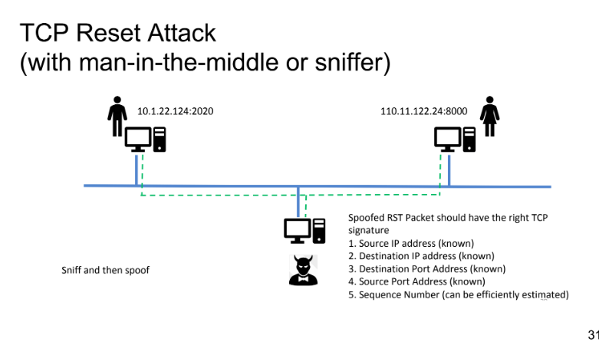
    - Session Hijacking
      * 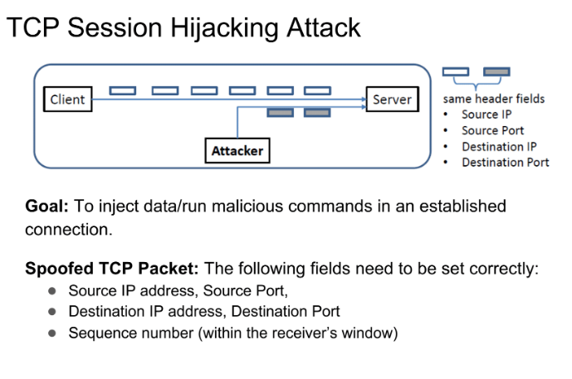
      * If a receiver has already received some data, and a spoofed packet uses the sequence number x + some number, it becomes out of order
        + Data in packet will be stored in receiver buffer
      * By using this method to hijack telnet connections, we can run arbitrary commands on the server
        + By using things such as cat, we can use this to steal secrets
      * 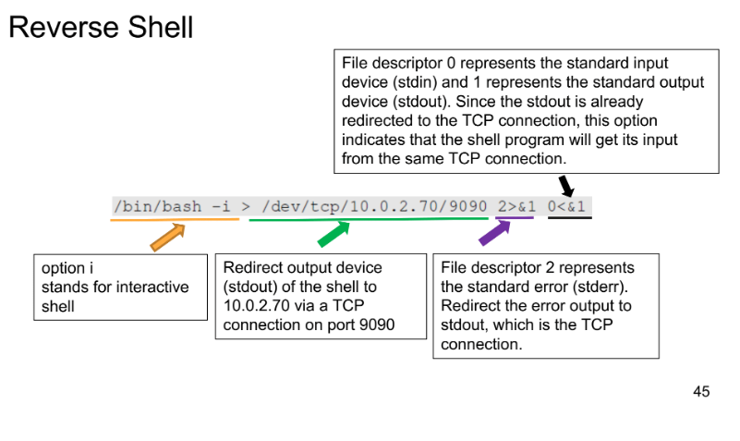
  + **Defenses against DDoS**
    - Hard
      * End to end paradigm
      * Internet security is highly interdependent
      * Resources limited
      * Intelligence and resources are not collocated
      * Accountability is not enforced
      * Control is distributed
    - Defense must match attack
      * Classify Attack types (I.E whether its a DoS or a DDoS attack)
      * Recognizable by packet header info and stream dynamics
    - Detect bad behavior that is a symptom of DoS without needing cooperation of an ISP
      * Spoofing, flows that violate TCP congestion control rules
    - Filtering Based defenses
      * Ingress Filtering
        + 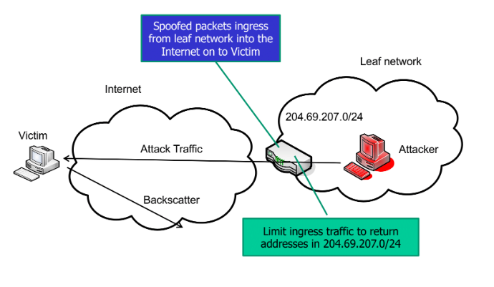
      * Route Based Packet Filtering
        + 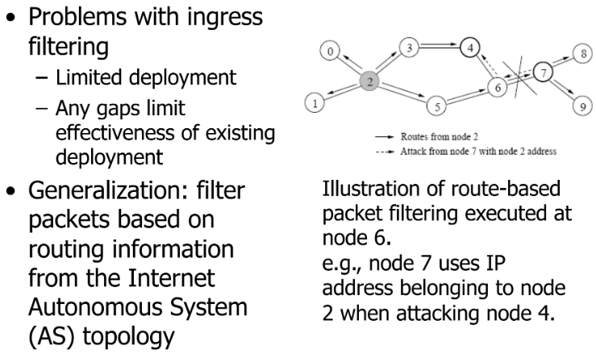
    - Proof based Defense
      * Requires some proof that the service for a client is desired or some evidence that would make it easier to eliminate unwanted requests
      * SYN Cookies
        + Encode info in the sequence # so server does NOT need to save anything for half open connection

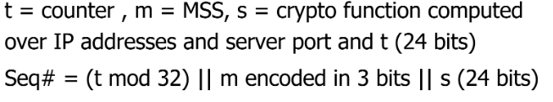

* + - * + 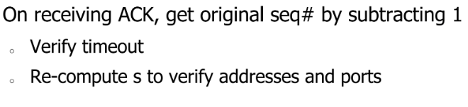
        + 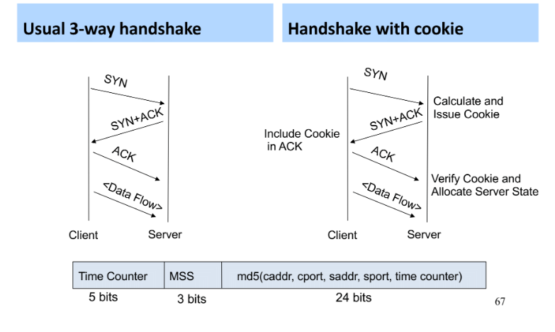
      * Proof of Computing Power
        + 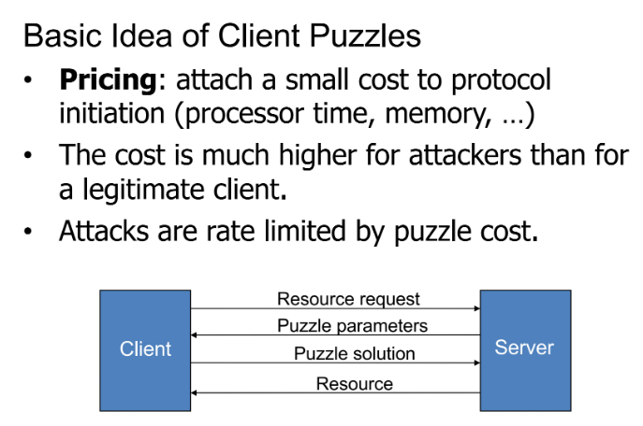
      * Hashcash puzzles
        + 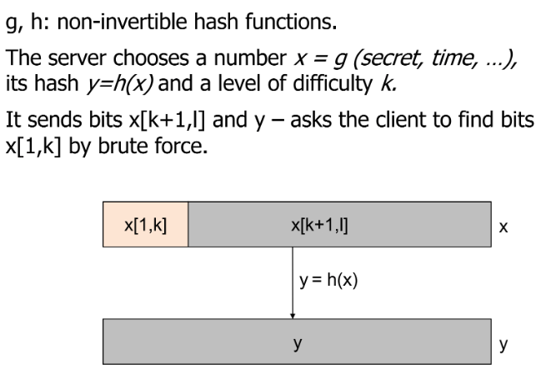
* **Intrusion Detection**
  + **Intruders**
    - An unauthorized entity attempts to gain access to a protected resources
  + **Intrusion Prevention**
    - Firewalls
    - Anti-virus
    - Authentication
  + **IDS**
    - Detect intrusion in progress (or after)
    - Look for unusual or suspicious activities
    - Actions after detection of intrusion
      * Alert authorities
      * Change firewall configs etc.
    - IDS elements: -
      * 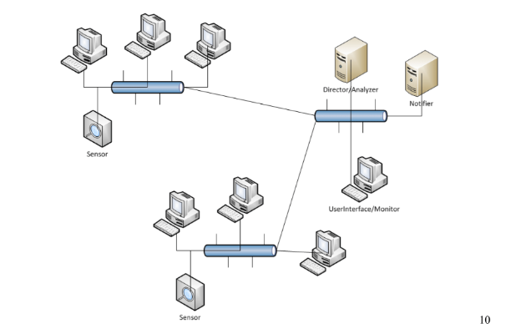
  + **IDS Types**
    - Signature based
    - Anomaly Based
    - Host Based
      * 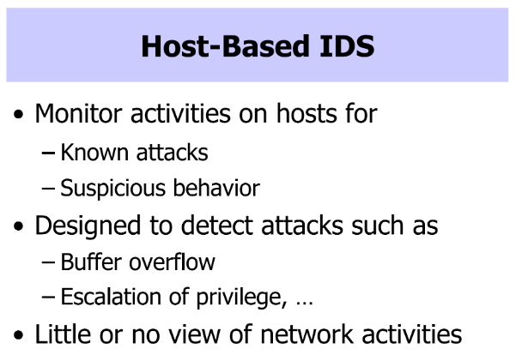
    - Network Based
      * 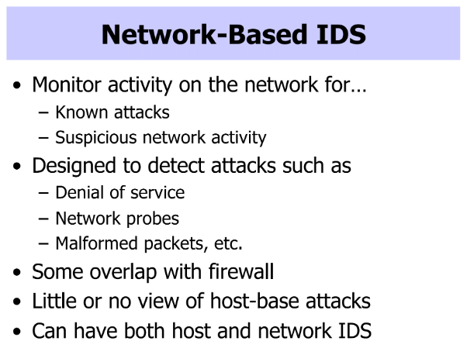
* **Firewalls**
  + **Different Types of Firewalls**
  + **Deployment Level**
* **Software Reverse Engineering**
  + **Tools**
  + **SRE Attack Mitigation**